Texas State Archery FITA Field Reminder Sheet for Order of Archer Shooting
 | ODD Number Target |  |  |  |  | ODD Number Target
 | “A” archer | “B” Archer |  |  |  | “A” Archer |  |  | “C” Archer | “B” Archer | “D” Archer
4  T  a  r  g  e  t  s | 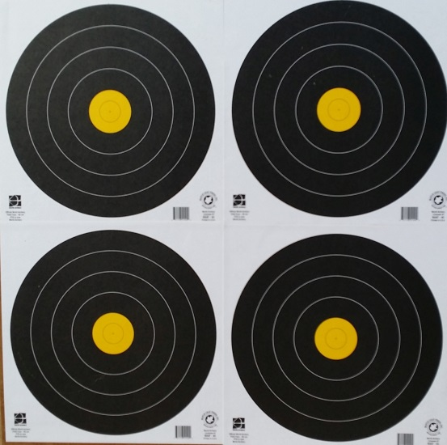 |  |  |  |  | 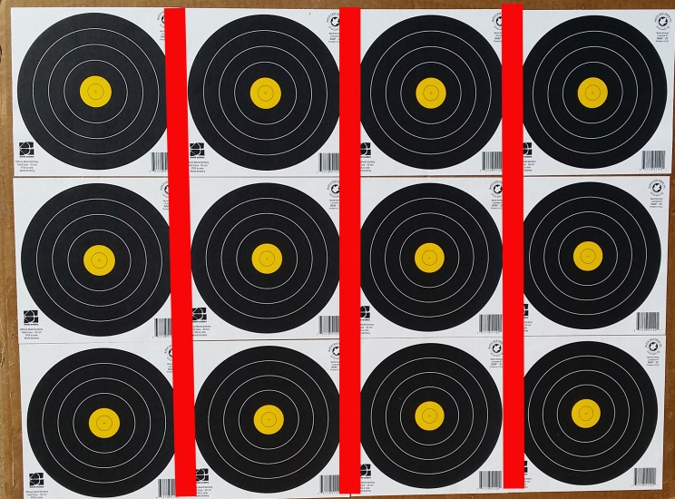 |  |  |  |  |  |  | 12  T  a  r  g  e  t  s
 | “C” Archer | “D” Archer |  |  |  | “A” Archer |  |  | “C”Archer | “B”Archer | “D” Archer
 | EVEN Number Target |  |  |  |  |  | EVEN Number Target
 | “C” archer | “D” Archer |  |  |  |  | “C” Archer | “A” Archer |  | “D” Archer |  | “B” Archer
4  T  a  r  g  e  t  s |  |  |  |  |  |  |  |  |  |  |  |  |  | 12  T  a  r  g  e  t  s
 | “A” Archer | “B” Archer |  |  |  |  | “C” Archer | “A” Archer |  | “D” Archer |  | “B” Archer
 | ODD Number Target |  |  |  |  |  | ODD Number Target
 | “A”& “C” archer | “B”& “D” Archer |  |  |  |  | “A” Archer | “B” Archer |  | “C” Archer |  | “D” Archer
2  T  a  r  g  e  t  s | 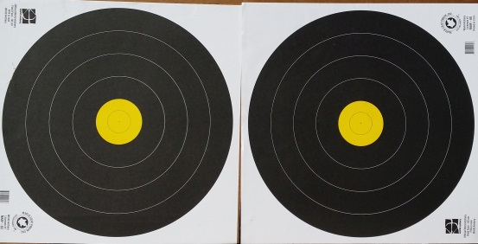 |  |  |  |  |  | 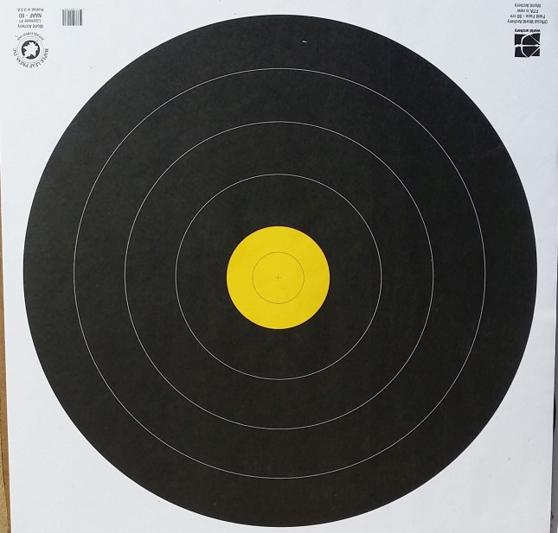  EVEN NUMBER TARGET |  |  |  |  |  |  | 1  T  A  R  G  E  T
 | EVEN Number Target
 | “B” & “D” Archer |  | “A” & “C” Archer
2
T
a
r
g
e
t
 |  |  |  |  |  |  | “C” Archer | “D” Archer |  | “A” Archer |  | “B” Archer

