**1215. Understanding Field Archery**

**An extract from the FITA Field Guidelines booklet published by FITA in 1995.**

# Overview

Field shooting is a popular archery shooting discipline in most countries but in order to make it more popular and easier for beginners to take up field shooting we will use this booklet to try and explain some of the "secrets" of field archery.

Shooting field archery is basically the same as shooting target archery, and very often one will find that a good target archer will also become a good field archer. However, as you will see there are quite a few things that should be kept in mind when shooting field - and this is what this booklet is all about.

In field shooting, all Archery Victoria divisions are accepted, meaning that there are divisions for Compound, Recurve and Barebow.

Compounds are mostly shot with a release aid and a magnified scope sight, and the archer will generally use the same equipment as on the target disciplines.

Recurve is shot with a recurve bow and uses sights and stabilizers.

Barebow is shot with a recurve, compound, limited compound or longbow without a sight or stabilizer; however, different aiming techniques are used, so that the archer can use the point of their arrow or their arrow rest as an aiming device.

The barebow archer will most probably "string walk" to vary the position of the arrow in relation to his aiming eye, or use different anchor points, or a combination of both in order to make it possible to aim in the middle at different distances. A low anchor point is used for the long distances and a high anchor point is used with the short distances.

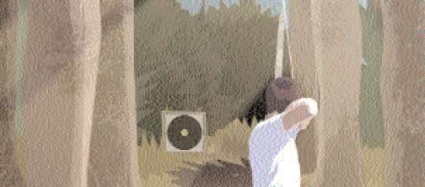

**Target Archery versus Field Archery**

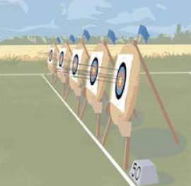

Field archery differs in some ways from outdoor target archery. The main differences being that an outdoor target archer shoots on marked distances only, some longer than in field archery.

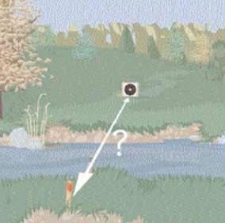

The field archer shoots on both known and unknown distances from 5 metres to 60 metres, depending on division.

The field archer needs to practice on many different distances, as well as practising how to judge the distance.

**Target Archery versus Field Archery**

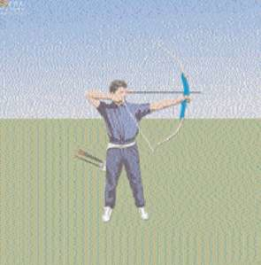

Target archery is shot on level ground, and the shooting position is usually the same.

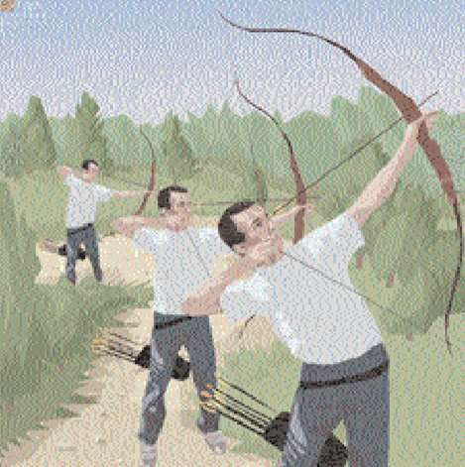

Field shooting is also a question of shooting uphill and downhill so the field archer needs to practice on varying shooting positions.

**Target Archery versus Field Archery**

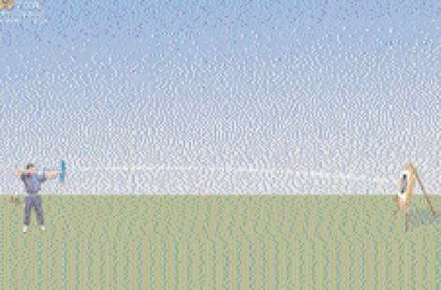

For target archery the arrow flight is the same for a given distance, only influenced by the wind.

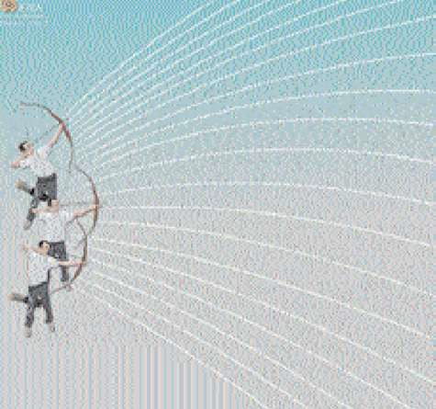

In field archery the arrow flight differs on a given distance due to the angle of the shot. A field archer must know by experience how much to subtract from the distance due to angle of the terrain.

**Target Archery versus Field Archery**

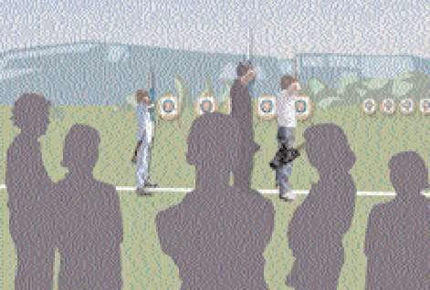

Target archery is always shot close to the competitors and spectators, which may lead to an increase in tension.

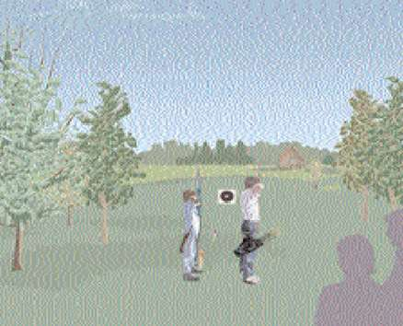

Normally, Field Archers shoot in their own group and not close to other competitors.

Spectators may be present at major International competitions.

Field Archers tend to feel less stress during competition.

**Target Archery versus Field Archery**

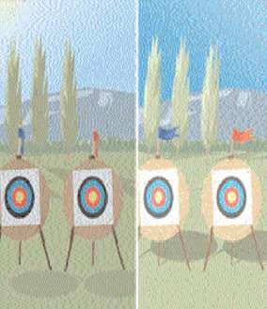

In target archery the light and wind conditions are usually stable and only gradually change throughout the day.

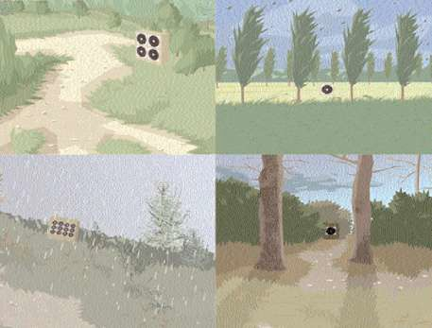

In field archery, light and wind conditions vary from target to target, but strong winds are rare due to the terrain.

The field archer must practice in varying wind and light conditions to learn how these influence their aiming and shooting.

**Target Archery versus Field Archery**

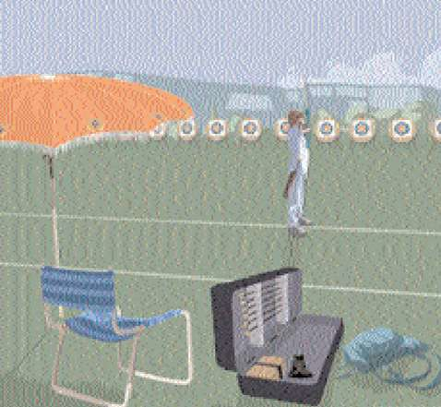

The target archer has all their equipment close by.

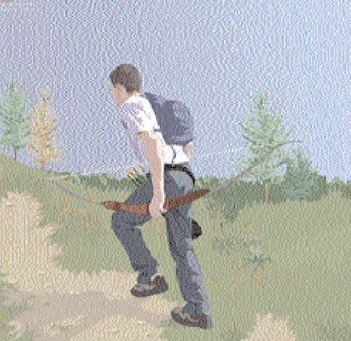

The field archer needs to plan and experiment with clothing and equipment in order to be prepared for "'everything". The field archer has to carry whatever is required with them.

**Target Archery versus Field Archery**

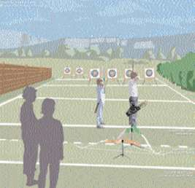

In target archery all the archers stand on a single shooting line and shoot in the same direction at a single row of targets

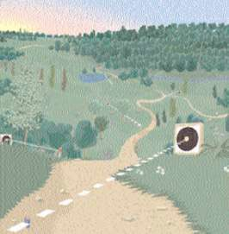

In field archery the principle is to use the terrain as it is. You are allowed to work the ground around the peg so your feet are comfortable but on most courses this would have been done over the years.

In all cases you should follow the path and/or the signs that the course designer has erected.

**Shooting Downhill**

On flat ground the basic position is the same "T" position as in target archery.

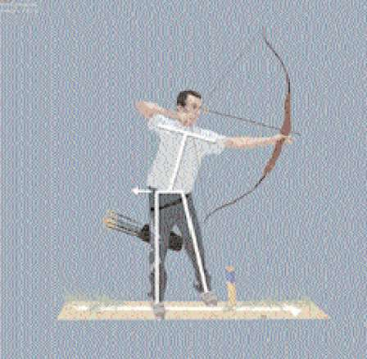

At slight downhill shots - with level foot position - move your hips backwards before the draw.

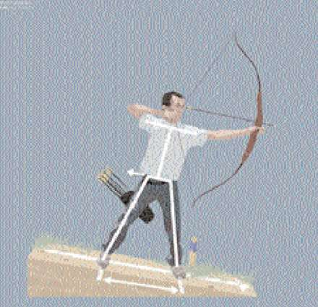

Downhill shot - sloping ground - feet wide apart - push hips away from the target.

**Shooting Downhill**

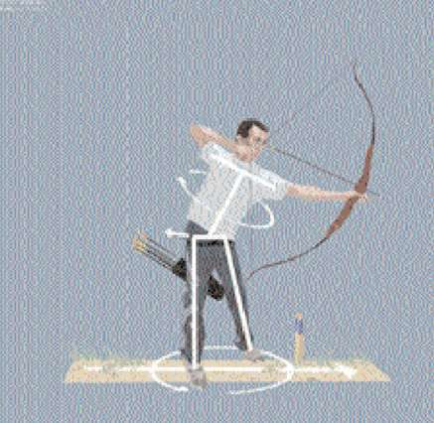

Steep downhill shot-level ground - open your foot position, move your hips backwards and straighten your upper body before the draw. The steeper the shot the more you will have to open your stance.

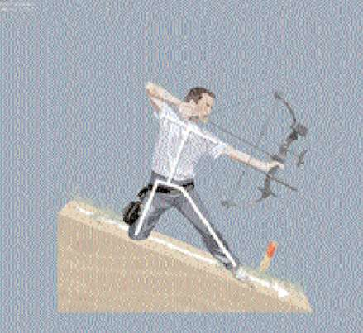

Very steep downhill shot extremely steep hillside. Sometimes your shooting position will become more stable if you kneel on your rear knee.

**Shooting Uphill**

On flat ground the basic position is the same "T" position as in target archery.

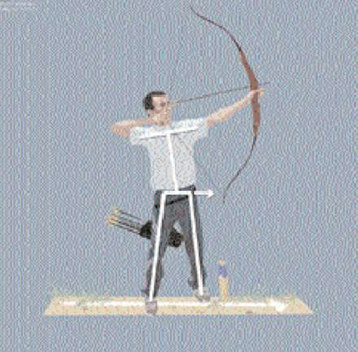

At slight uphill shots - with level foot position - move your hips forward before the draw. Keep the upper body part of your body and shoulders in a "'T'" position.

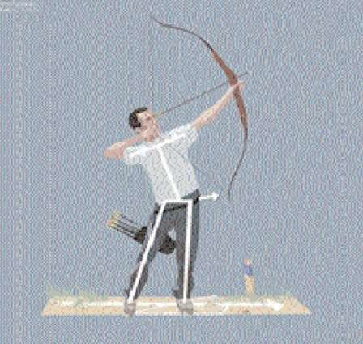

Steep uphill shots level ground - move the foot nearest to the target forward and move your hips forward before the draw.

**Shooting Uphill**

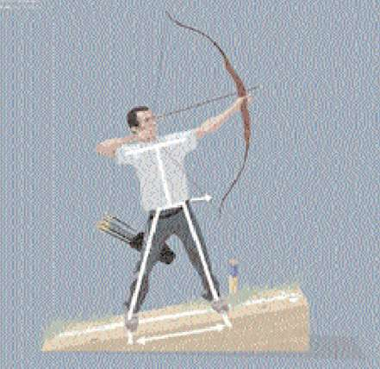

Uphill shot - sloping ground - feet wide apart - push hips toward the target.

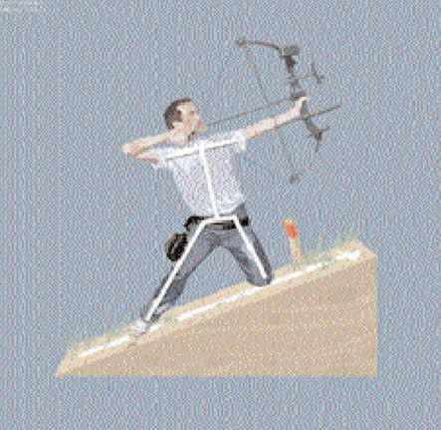

Very steep uphill shot, extremely steep hillside. Sometimes your shooting position will become more stable if you kneel on your forward knee.

**Shooting Across a Slope**

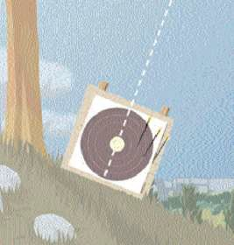

When shooting at a target on a slope the probability of hitting on the downhill side of the face is greater.

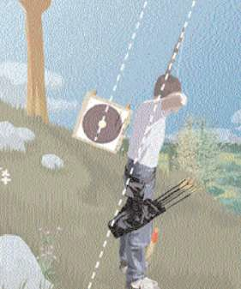

A probable cause to this sideways grouping is that you are leaning and/or the bow is canted with the angle of the butt.

**Shooting Across a Slope**

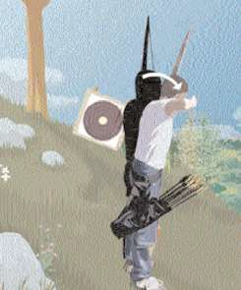

When you stand on sloping ground the archer will tend to "lean" downhill. Because the archer is leaning downhill it is probable the arrows will drift downhill.

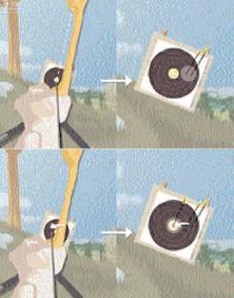

Archers that do not adjust the cant of the bow in this example should aim uphill on the next arrow. Where possible hold the bow in a vertical position.

**Shooting Across a Slope**

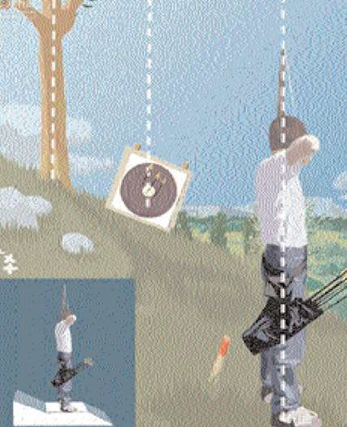

Vertical body position reduces the downhill effect.

Try to find a level piece of ground. You have the right to move a little behind the line, or around if it is a peg, as long as you do not obstruct your competitor.

Prepare the shot by leaning the top of the bow towards the hillside. At full draw, check your vertical alignment against a tree, or through an imaginary line through the target. Compound (scope) shooters will of course check their level. Always start by leaning the bow towards the hillside. This reduces the tendency of canting the bow away from the slope.

Line up your body in a vertical position, and make sure you are not leaning downhill.

If you are unable to stand in a vertical position, and your bow is still canting, you will have to aim a little to the opposite side of your cant. The longer the distance, the more you will have to move your aiming point.

# How to Judge Distances

When shooting the unmarked Field Round you need to judge the distances on targets you may have never seen before. To most field archers this is the challenge.

If you want to win such a tournament, you have to be pretty good at judging a distance because you are likely to meet some real experts out there.

But do not despair, all field archers started from scratch, and it is not really that difficult. Most people will be pretty close after a few trials, but remember, even the best "expert" may be fooled every now and then so don’t give up!

There are many techniques used for judging distances but you do need to practice, practice and practice to become really good at it.

The best practice is to take a walk in the field and guess the distance to a tree or a rock and then pace off the distance to check yourself.

Shooting a lot of field competitions on unmarked distances will obviously help also.

The normal method is that you compare the size of your sight (or the diameter of your arrow, etc) with the size of the target face, the size of the butt or anything else which size is known to you.

By experience you will know how much of the target butt or target face that is enclosed by your sight ring at different distances. Whichever method you use, you need to practice it and just to be sure we suggest you use a little of everything!

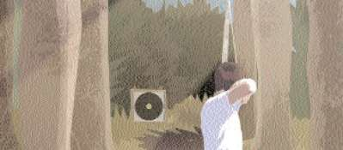

**Range Finding**

In Field Archery an important part of the shooting technique consists of making accurate range estimations on the unmarked courses.

In order to compete with the best archers this knowledge cannot be entirely dependent on your intuition, or on your terrain evaluation, as these methods are far too inaccurate and you will end up losing too many important points.

A field archer will have to find their own way to calculate the distances, and they will have to practice this as part of their shooting form. You may use any regular part of your equipment for instance a sight component, the arrow rest, etc. You may not attach any component solely for gauging.

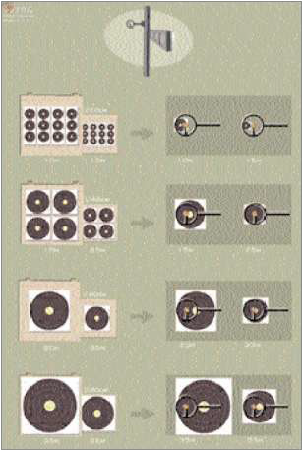

When you are practicing on different sized faces at different distances you should make up your own chart similar to the example. You will then have to memorise it as you cannot take it into the field course with you.

The Rules clearly state that the use of range finding equipment is not allowed and it also indicates that the archer should not use their equipment other than intended which means that when you gauge it should be part of your normal shooting routine.

It is known that trying to stop measuring by means of using your equipment is not possible, but the rules are trying to make sure that real range finders will not find their way into the world of field competitions. This is why the rules will allow you the above mentioned methods, but not allow you to alter your equipment to become a range finder.

**An Easy Gauging Method**

One of the easiest methods of gauging is treating all size faces as an 80cm. You need to memorise what the shortest distance, the longest distance and the average distance looks like on an 80cm face.

This can be done using your sight if you are a sighted archer or the arrow tip if you are an unsighted archer.



Left side of sight **30** 35 **40** 45 **50** 55 60

This is an example of a ringed sight on a recurve bow.

The archer needs to memorise where the outside (right side in this example) of the sight sits on the target for 30, 40 and 50 metres. This can be done for any type of sight or arrow tip.

Having memorised the three main distances the archer can now gauge any size face. As an example, a 20cm target may gauge as 40 metres. The 20cm face is a quarter of the size of the 80cm so the distance is 10 metres.

A 20cm face is 1/4 of the gauged distance.

A 40cm face is 1/2 of the gauged distance.

A 60cm face is 3/4 of the gauged distance.

The trick in field is identifying the 60cm face from the 80cm face. Perspective is the presentation of different sized objects at different distances so they look the same. When an 80cm face is at 47 metres and a 60cm face is at 35 metres they will look and gauge the same. When the course designer uses different sized butts it can be quite difficult to pick which face it is.

So when gauging a single face it should first be gauged as an 80cm and then decide if it is (say) 40 metres on the 80cm face or 30 metres (3/4 the gauged distance) on a 60cm face. If you cannot identify the face with confidence then there are a few backup methods to gauge the distance on the following pages. Feel free to use a combination of all the methods presented as no one method is fool proof.

**Target Face Identification**

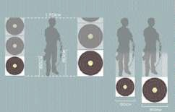

If you are shooting when there are other archers on the course then you may see them standing next to the target. By comparing the size of a body near the target, you can recognize a 60 cm from an 80 cm target face by comparing their respective sizes.

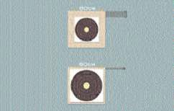

You only have to identify the difference between the two largest faces. For these sizes only one face is affixed to the butt. Most course designers use the same target butt size for their entire course. Hence you should note the margin size around the target face and you can identify if you are shooting on a 60 cm or 80 cm target face. Take care though because some course designers use different sized butts!

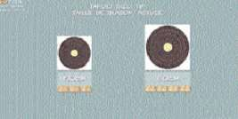

Since the size of the target number is usually the same all along the course, you can recognize a 60 cm from an 80 cm target face by comparing their respective sizes. In the example we can place three numbers across a 60 cm face while we can fit 4 numbers across 80 cm target face. Course designers know this and sometimes change the size of the number to trick you.

**Method for Judging Distances**

**The Judging by Feel Method**

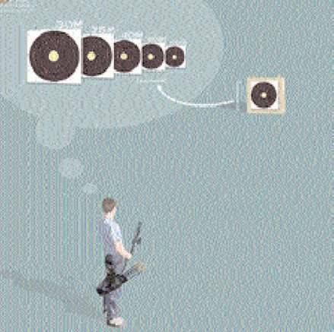

Judging by feel means that you learn to judge the distance by "feeling" the size of the target in relation to the distance. In order to do this you need to practice a lot, but here are a few suggestions.

Locate the different sizes of field faces on various distances (start with the maximum distances); shoot at the targets while getting accustomed with their sizes.

Locate the targets in the field, judge the distance by "feeling", shoot at them, and then pace or measure the distance.

Always remember the maximum distance for that particular target face. (you may be fooled on field targets, try to judge by the spot size rather than the whole face)

On average, most archers will judge the distance as too short.

# The Listening Method

If you are shooting with other archers you have the chance to listen how long it is from the time of release to the time of impact on the target. This technique needs a lot of experience but can be very accurate.

It is clear that the time necessary for impact is dependent on the poundage of the bow and the distance the arrow has to travel. However don't forget that you only have 4 minutes and that you should not delay competition.

**Method for Judging Distances**

**The Post Method**

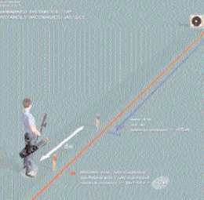

In the example this compound archer knows that the blue post can be no more than 45 metres maximum from the target (by rule). He estimates the red post at 5 metres from the blue one. He is therefore sure to be at no more than 50 m from the target.

The same principle works if the red peg is closer than the blue peg.

# The Middle Point Method

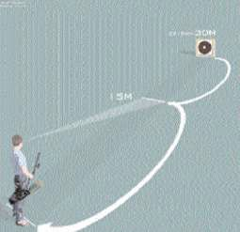

Try to find the middle point and judge the distance to that point. Then double the distance. If you misjudge the middle distance, you have doubled your mistake.

**Method for Judging Distances**

**The Intermediate Reference Method**

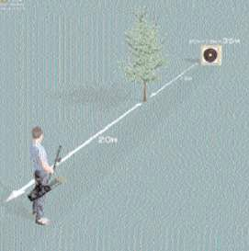

The archer estimates the distance between the target and a tree for instance (15 metres in this example). He estimates the distance between the tree and himself (20 metres in this example). Hence the total distance is 35 metres.

# The Addition Method

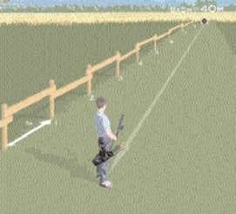

If you are shooting in a plantation type forest or along a fence etc. you can "add up" the distance to the target.

**Method for Judging Distances**

**The 10 Metre Technique**

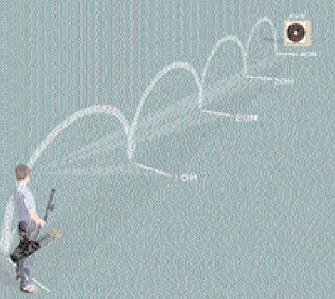

Learn how long 10 metres is in various terrains. Find a point which is 10 metres from you and "roll over" the 10m point until you are close to the target. Add or subtract the missing distance. Remember; if you miss by 1 metre in your first 10 metres, you will add on the mistake every time you "roll over" the distance.

If 10 metres is too difficult to get on the first go then go for 2 metre or 5 metre increments.

In most cases once you have gauged with your sight or arrow point then you are only looking for a confirmation of the distance. The example may be “is it 40 metres on an 80cm face or is it 30 metres on a 60cm face?” By learning what a 10 metre gap looks like you should be now very close to the actual distance and be able to shoot your arrow with confidence.

# The Other Persons Sight Setting Method

When shooting with archers that are using sights it will not take long to see where their 40 metre and 50 metre sight setting is. On an average male recurve bow, as an example, the 50 metre setting is usually at the bottom of their sight extension bar. The 40 metre setting is usually at the top of their sight extension bar.

**Understanding Optical Illusions**

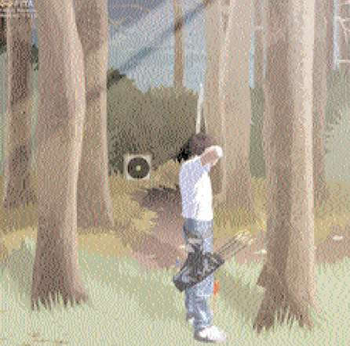

If you are standing in a brightly lit place shooting at a target in dark surroundings, you will normally judge the distance to be longer than it really is.

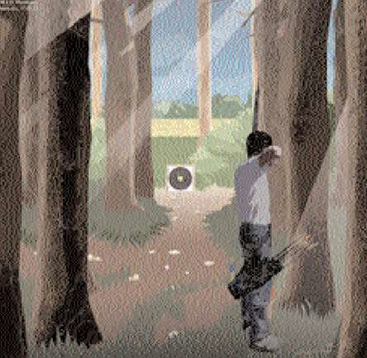

If you are standing in a dark place shooting at a target in brightly lit surroundings, you will normally judge the distance to be shorter than it really is.

**Understanding Optical Illusions**

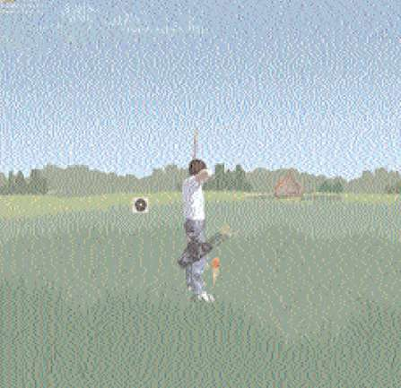

When shooting on an open field or across open water you may be fooled both ways, but normally you will judge it short.

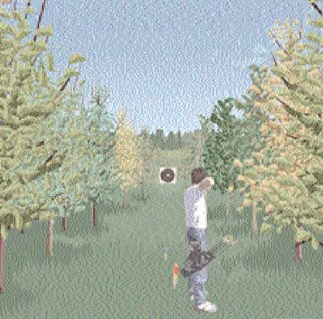

If the target is placed in a "corridor" of trees, you will normally believe it to be longer than it seems to be.

**Understanding Optical Illusions**

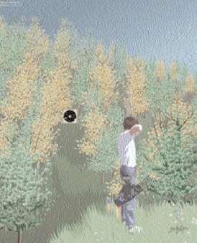

If you have to shoot across a valley, you will judge the distance longer than what it really is.

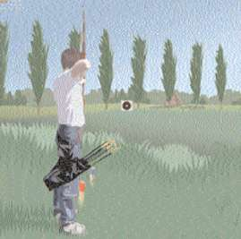

If you shoot at a target where you are unable to see the ground all the way to the butt, you will probably judge the distance too long.

**Understanding Optical Illusions**

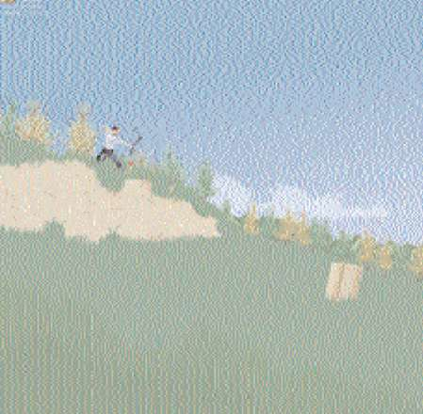

A downhill target is normally judged too long; also you may have to take off a couple of metres on your sight marks.

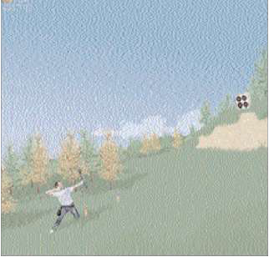

An uphill target is normally judged too short; also you may have to add a couple of metres on your sight marks.

**Understanding Optical Illusions**

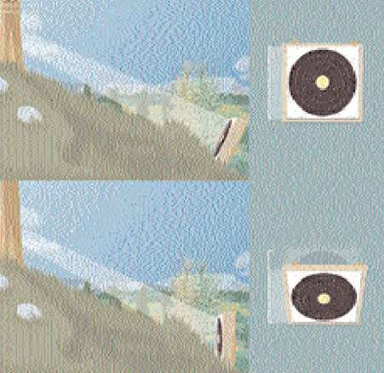

Also take care to the angle of viewing the target. The top illustration shows that the target is seen full size.

The bottom illustration shows that the bottom target looks squeezed. The rules limit such angles for setting the target butt but not all course designers will pick up the angle.

Sometimes the lay of the land limits how the target butt is placed.

If the target face looks small you will judge it as long.

**Understanding Gravity**

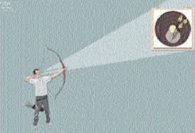

At a slight slope uphill add one or two metres to the real distance (dependent of the distance). The better the archer you are the less this effect will be. It is mainly required because most archers drop their arm on a gentle uphill shot.

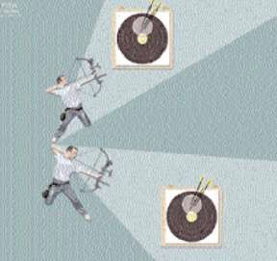

On a steep slope, deduct one or two metres from the real distance (dependent of the distance). On a very steep slope you may need to deduct 10 metres.

When you shoot 60 metres straight down a cliff face you will only use a 15 metre sight setting. This is because the arrow will fly straight at the target and will not have a curve in its flight.

Knowing how you bow works at different angles will help you understand why a 40 metre shot up a steep incline will require a much shorter sight setting.

**Ensuring a Good Second Shot**

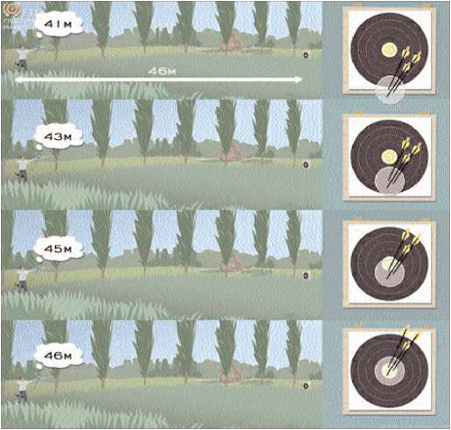

An experienced archer will know what a mistake of 5 metres will do.

In the first picture the archer has guessed 41 metres on a 46 metre target. The arrow should land just off the face. In the second picture they have guessed 43 metres making the arrows land in the two scoring zone.

In the third picture they have guessed 45 metres landing just under the spot.

You are allowed binoculars – use them. Unmarked field is designed to produce doubt and a good course designer will exaggerate that doubt. Always shoot your first arrow with confidence so if you have the wrong distance then the following adjustments shall be meaningful.

# Knowing Your Sight Settings

Following is an example of a sight setting tag that has been created in Excel. You are allowed to take a list of sight settings with you into the field.

You may also mark 5 metre increments on a tape that is on your sight bar.

In either case, unmarked field will present you with some non-uniform distances so it is better to know what your sight setting is for 37 metres (as an example) rather than trying to calculate it.

|  |  |  |  |  |  |  |  |
| --- | --- | --- | --- | --- | --- | --- | --- |
|  |  |  |  |  |  |  |  |
|  | **10m** | **200** | 27m | 330 | 44m | 522 |  |
|  | 11m | 206 | 28m | 340 | **45m** | **535** |  |
|  | 12m | 212 | 29m | 350 | 46m | 548 |  |
|  | 13m | 218 | **30m** | **360** | 47m | 561 |  |
|  | 14m | 224 | 31m | 371 | 48m | 574 |  |
|  | **15m** | **230** | 32m | 382 | 49m | 587 |  |
|  | 16m | 236 | 33m | 393 | **50m** | **600** |  |
|  | 17m | 242 | 34m | 404 | 51m | 613 |  |
|  | 18m | 248 | **35m** | **415** | 52m | 626 |  |
|  | 19m | 254 | 36m | 426 | 53m | 639 |  |
|  | **20m** | **260** | 37m | 437 | 54m | 652 |  |
|  | 21m | 270 | 38m | 448 | **55m** | **665** |  |
|  | 22m | 280 | 39m | 459 | 56m | 678 |  |
|  | 23m | 290 | **40m** | **470** | 57m | 691 |  |
|  | 24m | 300 | 41m | 483 | 58m | 704 |  |
|  | **25m** | **310** | 42m | 496 | 59m | 717 |  |
|  | 26m | 320 | 43m | 509 | **60m** | **730** |  |
|  |  |  |  |  |  |  |  |

**Know The Rules**

Unit for Unmarked Course.

These are the rules that cover a 12 target unit.

In Australia most courses are 24 targets being 2 units of 12.

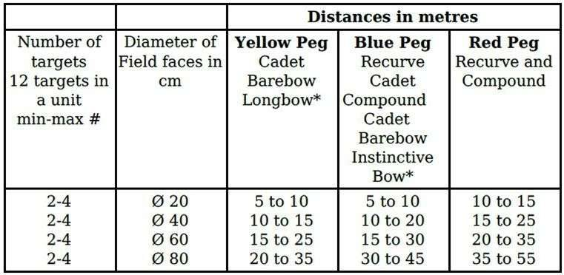

The distances of the three targets of the same size should vary between long, medium and short distances. This is to stop a course designer from making the targets for one size face all at the maximum distances.

Whilst the average distance for a red peg archer is longer than a blue peg archer that will not stop a course designer from having an 80 cm face with a 45 metre blue peg and a 35 metre red peg. Or, as an example, you may come across a 60 cm face with all three pegs at 22 metres.

If you know the rules for all the colour pegs you will calculate the distances easier.