***The Cushion Plunger***

From the time I first picked up a bow and started shooting arrows there has always been one part of the equation that makes it much easier to hit the target. Whether it is an animal, a stump or a paper target, you must be able to match your arrows to your bow for ultimate accuracy and forgiveness. This has not changed since the bow and arrow were first invented and continues to be an ongoing discussion with both target archers and bowhunters.

Arrow charts supplied by the manufacturers give us a good place to start with the process, however, they are not the holy grail as there are way too many variables involved with every type of shooting. Whether you shoot a long bow a recurve bow or a compound bow, there is one principle that does not vary and it is the main reason that arrows need to be matched to each bow type, bow weight, shooting style and archer. That one thing is ***Column Loading***.

Every time an arrow is shot out of any bow, the effects of Column Loading are applied, and because of that fact, every arrow that leaves a bow will bend in a certain configuration before it crosses the arrow shelf and it will continue to do so until the arrow reaches its target. That bending configuration is directly related to the stiffness or spine of the arrow, the arrow length, the point weight, the type of bow applying the force and the type and efficiency of the release method used.

To explain a little further, Column Loading is simply measured in the amount of force or weight placed on a column. If you continue applying force or weight, eventually the column will buckle or fail. The larger the diameter of the column the more weight it can bear given the same inside construction or cross section density. The longer the column or the smaller the diameter or both will cause the column to fail with less weight. If the force is applied in a direct line with the column, it will withstand considerably more weight than it would if the column is at a slight angle when the weight is applied. The arrows we shoot are simply a type of column and the outside diameter and inside wall thickness and material used will determine the bend or fail rate.

When an arrow is shot from a bow, it takes a certain amount of force applied to the column (arrow) to get it to move forward. The heavier the arrow the more it will resist movement causing it to absorb the energy as it starts to move forward. The overall weight of the arrow and its resistance to movement will cause the arrow to bend. If there is more weight placed in the front of the arrow it is similar to placing a wall in front of the column (arrow) and when the force is applied it will cause the column (arrow) to bend more. This is why changing to a heavier point weight will effectively weaken the spine or bending of an arrow.

If the column (arrow) is on a slight angle when the force is applied it will be much easier for it to bend. This is very evident in watching high speed film of a finger shooter. As the arrow moves around the archers fingers it causes the back end of the arrow to move out of direct alignment with the force being applied. This in turn causes the arrow to have a horizontal bend applied to it as it starts forward and sets up a figure 8 track for the string and the rear of the arrow shaft. This horizontal bending continues throughout the arrow flight until it reaches the target. The arrow will bend or cycle three times before it leaves the bow and in order for it to clear the bow without contact the stiffness or spine of the shaft needs to be correctly matched to all variables. Some of these variables include; the type, length and weight of the bow, the arrow length, the draw length of the archer, the arrow weight, the arrow point weight, the type of nock used, the type and weight of the fletching, the brace height of the bow, the tiller of the bow, the nocking point position, the type of string material, the type of serving material, tab type and material, release type, string loop type, compound bow let off percentage, type of cam used and probably several others that some of you may come up with from your own experiences. In other words, there are a lot of variables to overcome.

For the purpose of this article I am going to focus on one part of the equation that seems to continue to be a mystery or at best, misunderstood. That piece of equipment is a cushion plunger. First let me give you a little history of the cushion plunger.

The cushion plunger was invented by a man named Norm Pint. Norm and his wife Shirley had an archery shop in Iowa and they were both PAA shooters back in the 1960’s. He called his invention a Panic Button and put it on the market in the mid 1960’s. Since virtually none of the bows were drilled and tapped for any kind of lateral spine point, you were required to drill a hole in your riser to install his panic button. Most of the bow handles were made of wood at that time and you had to have some confidence that this thing would work before you put your favorite bow in a drill press. Consequently the Panic Button was not as popular as it could have been or was destined to be as the bows progressed.

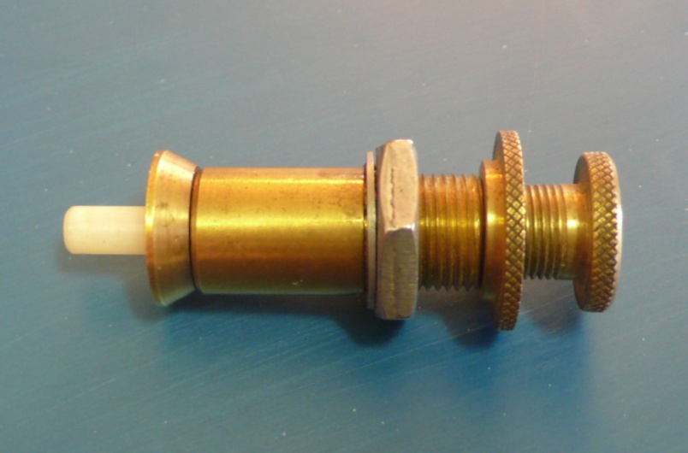

***This is an Original Panic Button, note the tapered front piece and the sleeve that fits inside the drilled hole in a bow handle.***

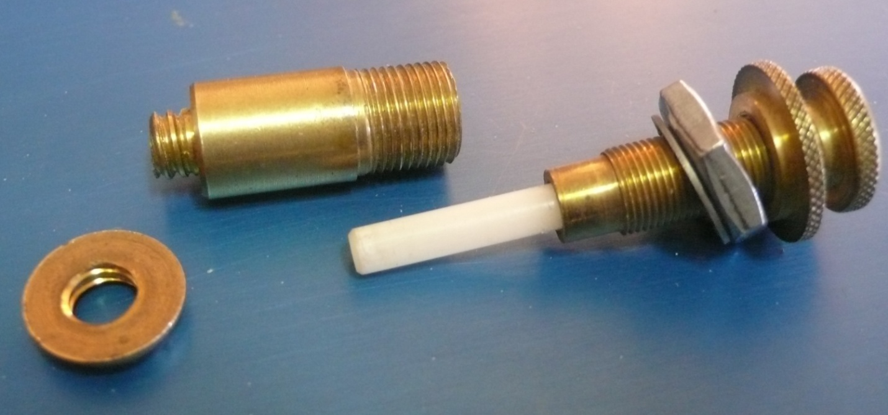

***This photo shows the different parts of the Original Panic Button. There was an adjustment for spring tension and a separate adjustment for center shot. The separate sleeve was held in place by the tapered front piece and the silver lock nut and lock washer on the opposite side of the bow window.***

The instructions for the Panic Button explained that the advantage to the device was that it would help correct your arrow flight on those shots when the archer tended to panic a little and not have the smoothest release. In other words it was not intended to correct arrow spine but merely it was there to help correct for some of the inconsistencies of the archer. That statement is still true today. ***Other than very minor effects, the cushion plunger will not correct poorly matched arrow spine, period!!*** The principles of column loading still apply.

A few years after Norm started marketing his Panic Button, the bows started getting a little more sophisticated with metal risers and take down bows beginning to hit the market. Along with that the manufacturers began putting a drilled and tapped hole in the riser to accommodate and adjustable spine point. About that time Vic Berger started manufacturing his own version of the Panic Button and he called it the Berger Button. Vic was one of the best recurve shooters I have ever seen and was a very popular figure in the archer arena at the time. Vic sold a considerable number of Berger Buttons and consequently whenever anyone talked about a cushion plunger they called it a Berger Button no matter who made the product. Most people assumed that because Vic Berger sold so many plungers that he actually invented it. It is amazing how many people I have had to correct over the years when they refer to a cushion plunger as a Berger Button.

The biggest problem with the Berger Button was in its lack of precision and the type of material used. The original Berger Buttons were manufactured out of an unanodized aluminum body with a steel stem. When the button got wet the aluminum would oxidize and the button would seize up and become rock hard. This problem happened to me while I was doing shows for the Calgary Stampede in the early 1970’s. It was rather embarrassing as I was unable to hit even the simplest target until I figured out what had happened. I vowed at that time that I would design a plunger that would not have this problem.

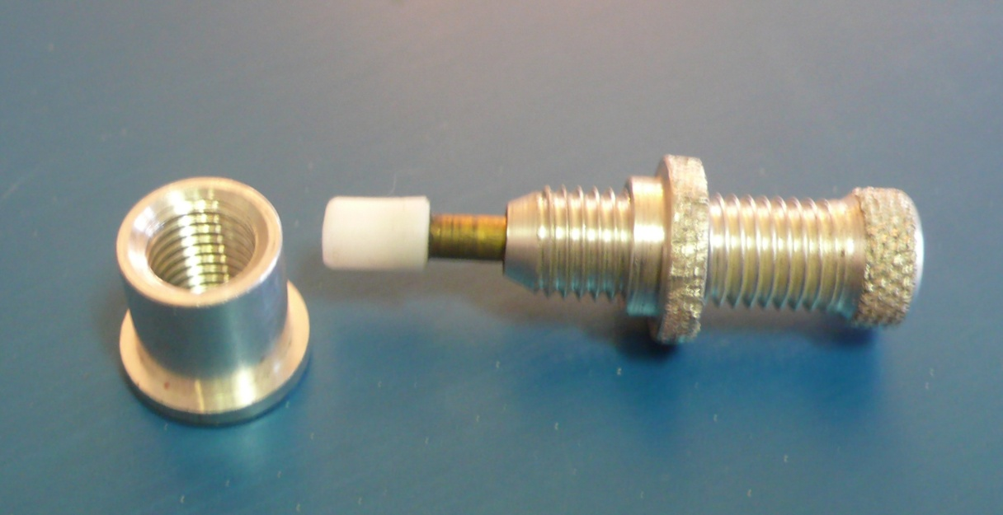

***An original Berger Button made of non anodized aluminum. Note the sleeve that came with the plunger that was designed to be glued in to the hole in the sight window of a bow.***

One of the top recurve archers for many years Mr. Al Muller, had also experienced the problems with a Berger Button and he solved the problem by manufacturing his own cushion plunger that was considerably larger and employed a polished stainless steel shaft that would move inside a Teflon sleeve in the housing of the plunger body. His was by far the best plunger I have ever seen but the sheer size of it made it very difficult to manufacture or market.

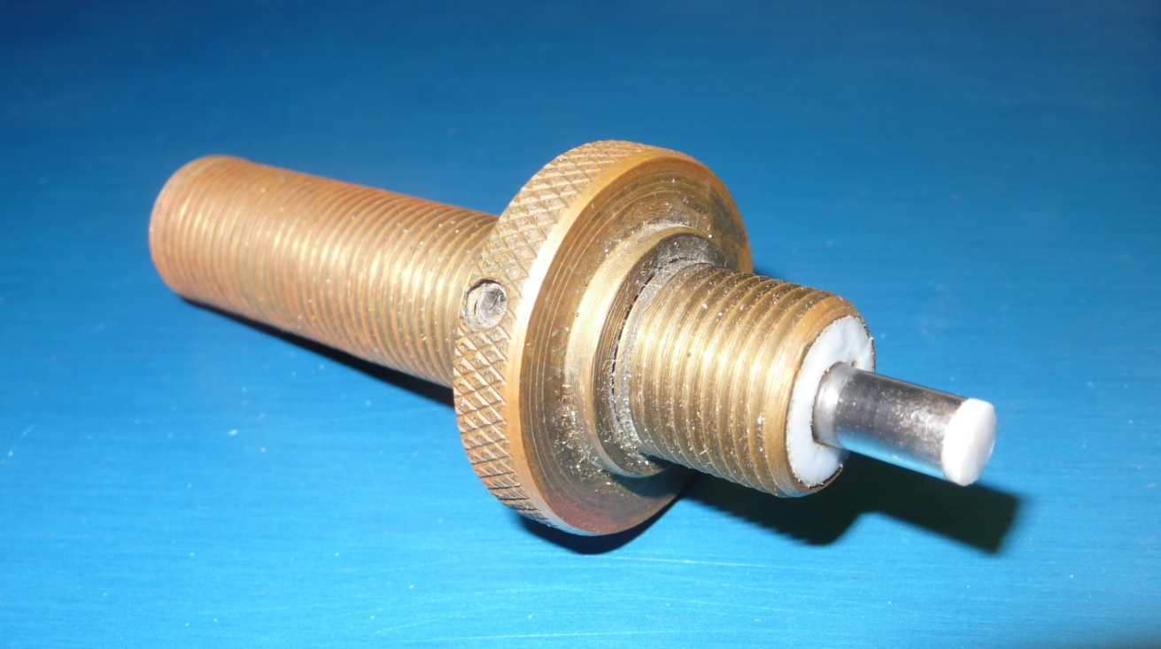

In the early 1980’s there was a large influx of plungers that were being made in Asia and these plungers became the choice of the serious target archers world wide. I was still not convinced that these new plungers were as good as the one that Mr. Muller had produced. I placed a phone call to Al and asked him if he would mind if I used some of his principles to produce a cushion plunger of my own. He gave me his blessing and we started making prototypes for testing.

When the arrow starts forward during the shot it places a certain amount of side pressure along with forward pressure on the spine point or cushion plunger. It stays in contact and rides along the cushion plunger for a very short distance before the bend in the arrow is reversed and it loses contact. That distance is maybe 4 to 6 inches depending upon the arrow type etc. Not a very long time to have an effect on the shot. However, it is the forward and side pressure that happens at the same time that showed the inconsistencies of most of the

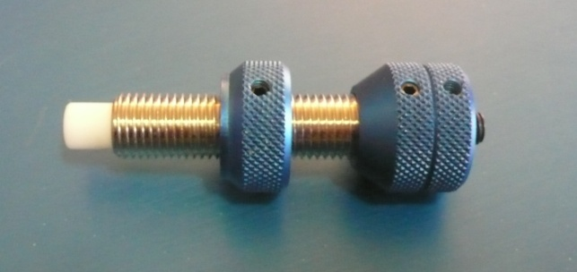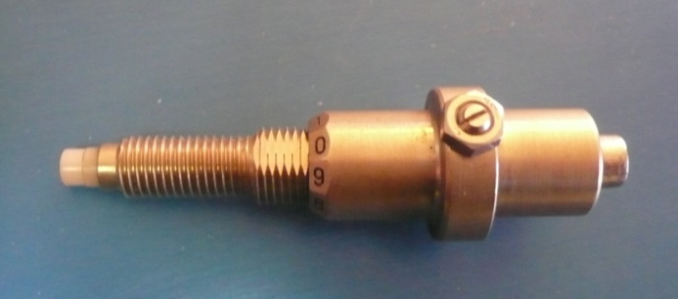

***Early Shibuya Plunger and an early version of the popular Beiter Button***

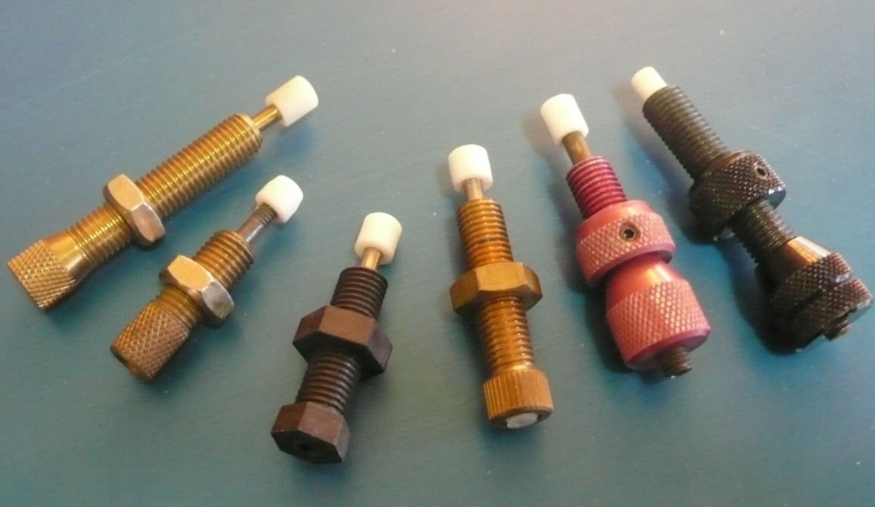

***A small selection of plungers that were on the market.***

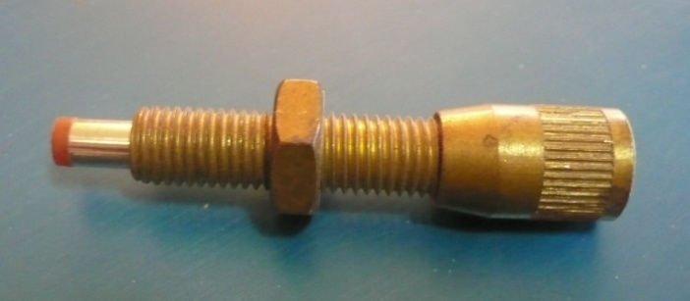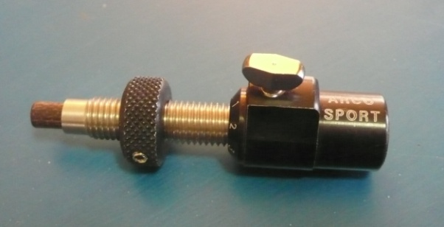

***A Saunders plunger and an Arco Sport plunger.***

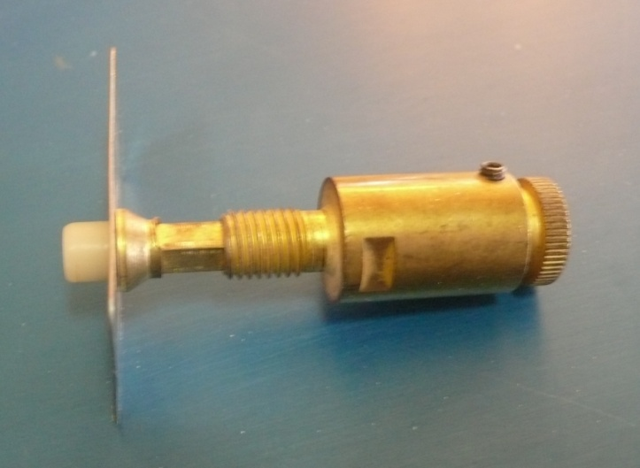

***This version had a plate for a stick on arrow rest and a square shaft to keep it from rotating. A good idea that wasn’t well received.***

plungers on the market at the time. We were determined to make a plunger that would not show those problems with side pressure or with changes in weather conditions.

What we developed was a stainless steel barrel with a Teflon sleeve very similar to what Al Muller had done with his plunger. We put a precision polished stainless steel shaft in it with a small Teflon tip on the end. We incorporated a tapered spring that came in three different weights that allowed for a very consistent movement and an unlimited adjustment range. Anodized aluminum lock rings and adjustment housing completed the package. The Cavalier Master Plunger was born.

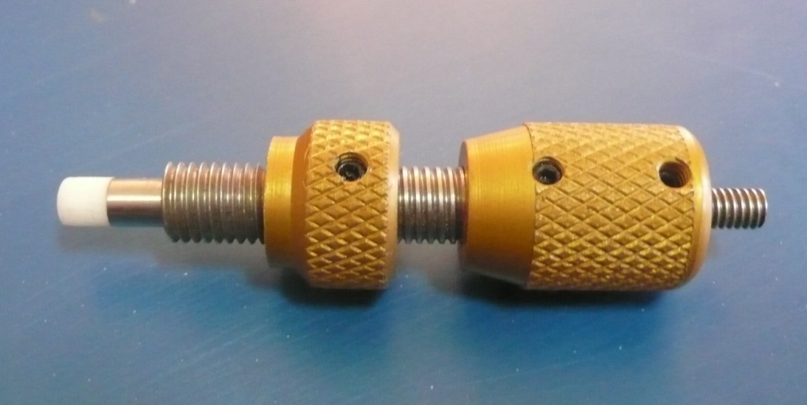

***Original Master Plunger about 1982***

It took very little time for this product to take off at an amazing pace. Top shooters around the world would write us and tell us about how much the product had improved their performance and ease of tuning their equipment. Over 30 years later and it is still one of the best if not the best plunger on the market today. There are considerably more expensive plungers on the market today with various adjustment features but when it comes down to consistency and reliability the Master Plunger is still hard to beat. There was a time when archers using the Master Plunger, Elite Tab and a T-300 rest owned every World and Olympic Record. It is hard to argue with success.

For quite a few years I worked with the USAT Teams on equipment and coaching. During those years we would have one or two camps a year to help the team members and to do testing for future team members. During one of those camps which was being held in the Houston, Texas area at the time I was asked a question about tuning during a ladies only session. Since most of the ladies had their equipment tuned by their coach, husband or boyfriend, they wanted to know how to tune a cushion plunger on their own. Here is the answer that I gave them at that time. I wrote it up as a separate article quite some time ago, so here it is.

***THE TONE METHOD OF TUNING YOUR BOW***

***WITH A CUSHION PLUNGER***

There seems to be a lot of confusion in the archery world as to what a cushion plunger actually does and what it doesn't do. To clarify some of the confusion and possibly help some of you achieve a better set up, I have put into writing the method that I use to tune a ***Cushion Plunger***. (As a little side note: The ***Cushion Plunger*** was invented by Mr. Norm Pint of Pinetop, Arizona in the mid 1960's and was originally called a panic button.)

The Cushion Plunger has only two functions in regards to its operation on your bow. First it serves as an adjustable spine point allowing the archer to adjust his or her center shot to achieve the necessary amount of clearance for vanes or feathers. Second, it helps correct some of the small errors that we make while executing the shot. This is done most efficiently when the spring tension of the plunger is set correctly, thus creating a less critical, very forgiving setup. A plunger is not a cure all for poor form, improperly spined arrows or any of the large errors we sometimes make while attempting to become a shooting machine.

With those points in mind, I will tell you a method I have used very successfully to achieve proper arrow flight and a forgiving setup with a cushion plunger.

The first step in tuning your bow is to determine if your bow is in proper line. This is easy to accomplish with a recurve bow, however, it can also me done on a compound bow with the following method. With your bow strung, lean it against a wall with the belly of the bow facing you and the bow as straight up and down as possible. Stand directly behind the bow and closing one eye, line up the bowstring with the center of the top limb. Now without moving your head look and see where the string lines up on the bottom limb. Compound bow shooters should realize that the position that the string cable comes off the wheel is the center of the bow. This is generally slightly left of center for a right hand bow. There are also several items on the market that can be used effectively to find center shot on your bow. EZ Crest makes a laser type device for compound bows and I have seen several other types made for compound bows. Beiter has a limb attachment system for recurve bows that works great.

Once you have determined that your bow is in line, remove your cushion plunger from your bow. Next take the spring out of your cushion plunger and place a match stick or a toothpick or any other solid material in its place and put it back together. Your plunger should not have any play or give to it at all. In other words, you now have an adjustable spine point with no spring tension.

Next, loosen the lock ring of the cushion plunger to allow you to adjust the center shot of your arrow. Place the plunger back into your bow and adjust the center shot of your arrow until the arrow is dead center in your bow. This is accomplished by propping up your bow as you did when checking the alignment and placing an arrow on the string, and on the arrow rest. Now you can move the plunger in and out until the string splits the arrow down the center. With a compound bow you must remember that the center of the bow is where the string cable comes off the wheel and not the center of the bow handle or limbs. You may have to measure this distance at the top of your limb and make a mark on your limb at the point that the limb enters the handle in order to line up the string properly on center. Once this is all accomplished, we can begin to tune your bow.

First, select the shaft size that is recommended for your bow weight and draw length. If there are several shafts that you can shoot, prepare a shaft from each size by removing all fletching. In other words we are going to use bare shafts to do our first series of tests. Now, standing approximately five yards from your target, shoot the bare shaft or shafts in the backstop at approximately shoulder level. I like to use a backstop material that will allow the arrow to enter without deflection. Some people prefer to use a large piece of paper stretched over a frame. By shooting through paper and reading the amount of tear, nocking point and arrow flight can be determined. If you are familiar with this method, it can be used at this time.

If at this time, your arrow enters the backstop with the nock high, your nocking point is generally too high. If the nock of your arrow is low, your nocking point is too low. This will show up as a vertical rip in the paper. Adjust your nocking point until the arrow enters the backstop parallel to the ground at shoulder height.

As you continue to shoot with the bare shaft you will notice a pattern in the way the arrow shaft enters the backstop. If the nock of the arrow ends up to the right, the arrow is too stiff in spine. If the nock of the arrow ends up to the left, the arrow is too weak in spine. The ideal arrow will enter the backstop straight. At this point you may have to try several size arrows to find the one that will enter straight or that will shoot through paper and leave a very small hole. If you find that there is no such arrow for you, pick the closest shaft that is slightly on the heavy side. In other words, nock slightly right for a right handed shooter.

To simplify matters, I also recommend that you start with 7% or standard weight points. If your shaft is slightly on the heavy side, add weight to your point with the Easton PWS system or use slightly heavier points. With the PWS system you can add five grains at a time until your arrow enters the backstop straight.

Once you have determined the proper shaft size for your bow, etc., the next step is to shoot the same arrow with the vanes that you intend to use. If the arrow does not enter the backstop correctly with the fletched shaft, the fletching is probably hitting the bow or rest or plunger as it leaves the bow. You may have to turn your nocks slightly to prevent fletching contact with the bow. It is very important that the arrow leaves the bow clean at this stage or the remainder of the steps will not necessarily work.

Next, put up a 40cm target face and move back to 18 meters or 20 yards. Your plunger remains as it was and should have no give at this time. Shoot your fletched arrows and move your sight until you achieve a good group in the middle of the target. If at this time you cannot group, you either need work on your form or your fletching is still hitting. Shoot several groups until you are certain that your group is centered on the target.

Next, loosen up the lock ring of your plunger and move the plunger out to the left (right handed shooter) until you can see the entire shaft left of center of the string at the point. Do this by propping up the bow as you did at the beginning and closing one eye as you did when lining up the arrow for the first step. When you have the arrow adjusted, shoot another three or four arrows and you will notice that your group has now moved to the left*.* ***Do not adjust your sight for this*.** Instead, remove the match stick or toothpick from your plunger and replace the spring. Now, by adjusting the spring tension, you can make your group return to the center of the target. Shoot several groups until you are certain that the group is centered on the target. Now you are certain that the plunger tension is correct.

To test your set up, shoot three fletched arrows at the target and follow it with the unfletched shaft. The unfletched shaft should fly well and enter the target between 8:30 and 9:00 in the eight or nine ring of a 40cm target face at 18 meters. If it enters the target too far to the left, the arrow is generally a little stiff. An incorrect nocking point will also show up with the bare shaft test at 18 meters. If the bare shaft ends up in your group but not to the right of the group it is also acceptable.

As a further fine tuning test, shoot a few groups at a longer distance such as 70 or 90 meters and check to see if the groups are circular. A vertical group can be corrected by a slight nocking point adjustment or tiller adjustment. A horizontal group can be corrected by a small spring tension adjustment.

This completes the method that I use and if all steps are followed correctly, this method will work for most all archers, compound or recurve. It allows the Cushion Plunger to move only far enough for the arrow to reach the center of the bow. It should not allow the arrow to move inside center which will cause your groups to open up. This will give you a very forgiving setup.

The next day at the camp, I gave each of the women a brand new plunger and they were given the task of setting up their own bow and tuning it using this method. After an hour or so, everyone had it done and it was not too much of a surprise to see each of them shooting much tighter groups and exhibiting a lot more confidence in their equipment and abilities. The men were watching as the women went through the process and were more than impressed with the outcome. That evening , during a question and answer session, one of the men on the team asked me to give them the same information about tuning their plunger that I had given the women the evening before. Before I could answer, several of the women on the team blurted out, “Don’t tell them”. Obviously it got a lot of laughs and I was more than happy to share the information with the guys also.

There have been many other methods used for tuning a recurve bow over the years that work very well. Paper tuning is very effective, bare shaft tuning at longer distances also works very well. Whatever method you ultimately use to tune your equipment there is one fact that does not change. ***Adjusting the tension of your cushion plunger has very little or no effect on the spine of your*** ***arrow.*** Matching your arrow shaft to your bow is the first step that must be taken before you can get the ultimate forgiving set up that will shoot world class scores.

I hope you enjoyed this visit to the history of the cushion plunger and a little about what it does and does not do.