Sun Devil Archery

at

Arizona State University

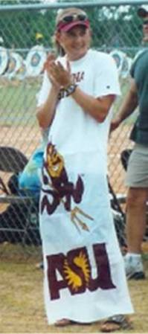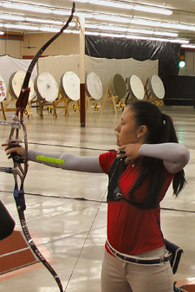
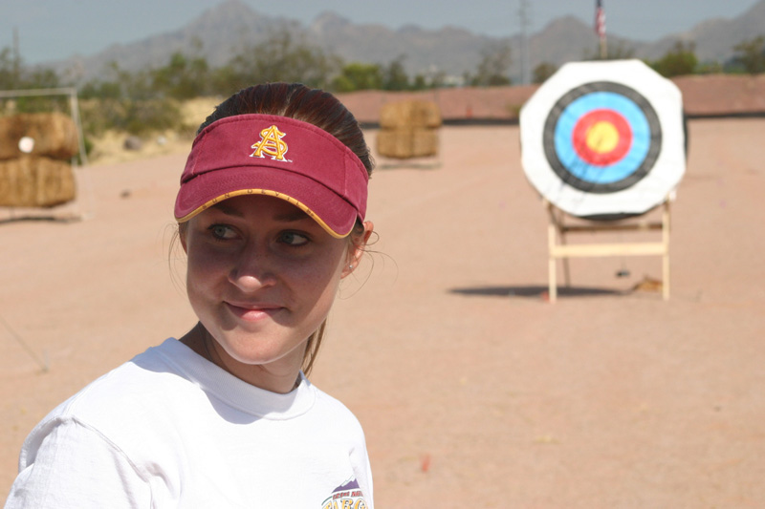

Risk Assessment / Safety Report

September 12, 2005
History of ARCHERY

Archery is one of the oldest arts of ancient times which is still practiced today. From its first development until the 1500s, the bow was man's constant companion and has been the most widely used of all weapons in recorded history. The bow allowed the prehistoric human to become the most efficient hunter on earth, providing him safety, food and raw materials such as bone, sinew and hide. From that time on, archery has played an important role in many of the world's civilizations.
Starting with the reign of William the Conqueror, the bow was England's principal weapon of national defense for several centuries. Around the year 1200, Genghis Khan and his Mongol hordes conquered much of the known world employing short, powerful bows. For Native Americans, archery was the means of subsistence and existence during the days of English and later American colonization. Finally, after the bow's replacement by firearms as a weapon of war, archery became a favored sport, thus securing its continuous practice throughout history.

According to Encyclopedia Britannica, archery's importance as a cultural advance ranks with the development of speed and the art of making fire. The use of the bow appears in folklore from over 3000 years ago, although its invention predates that era.

The development of archery followed a course of key innovations by many historical cultures. About 3500 BC., Egyptians were using bows as tall as themselves. Their arrowheads, originally constructed of flint, were later made of bronze. Almost 2000 years later, the Assyrians developed the shorter recurve bow, which provided more power and easier handling. One central Asian clan, the Parthians, became famous for their ability to shoot backwards from a galloping horse, making the Parthian shot a meaningful phrase in our language. At about 1200 BCE, the Hittites developed the skill of shooting from moving chariots, and around 500 AD, the Romans, formerly second-rate archers, began to draw the arrow to the face rather than the chest, giving the shot more accuracy.

There are many legendary stories and heroes which find their roots in archery. Homer's hero, Odysseus, reclaimed his wife and household upon his final return through his ability with his bow. The ancient Olympic games, tradition holds, were founded by an archer named Hercules. The Games featured archery with tethered doves as the targets. Target archery is also seen in the legends of Robin Hood and William Tell, which show the respect that the English had for great archers. In Japan, the practice of Kyudo and Yabusame raised archery from mere discipline to an art form and a philosophy of life.

Crossbows and the later developed longbow were the primary defense against massed cavalry. In the battles of Crecy and Agincourt in France, in the 14th century, English longbows overcame frightful odds against mounted, fully armored knights to win the advantage. These longbows had draw weights of from 60 to 120 pounds, and were often used at ranges up to 250 yards. From 1330 to 1414, English kings banned all other sports because they diverted time from archery and a royal decree of 1363 required all Englishmen to practice archery on Sundays and holidays. The advent of gunpowder lead to a decline in popularity for archery as a tool of war, but it never completely died away, particularly among peasant poachers in the King's woods.
The National Archery Association (NAA) of the United States (this country’s archery governing body as set by the United States Olympic Committee) had its origin as a result of just such a turn in our own country's history. After the Civil War, Confederate soldiers were not allowed to own firearms. Two brothers - J. Maurice and William H. Thompson - learned to hunt with the bow and arrow and became accomplished archers in Florida. Maurice's seminal book, “The Witchery of Archery,” along with his poetry, continues to charm people to archery to the current day. They were both founding members of the NAA in 1879 at Crawfordsville, Indiana.

Archery tournaments, as we know them today, can also be traced back to England. Competitions were held as part of community festivals as early as the 17th century. By about 1600, three kinds of shooting were practiced in England, and they still survive in some form. In butt shooting, the ancestor of Olympic target archery, bowmen aimed at targets mounted on earthen butts at ranges of 100 to 140 yards.

Archery became an official event in the modern Olympic Games in 1900 and was also featured in 1904, 1908 and 1920. International rules had not yet been developed, though, and each host country used its own rules and format. Because of the resulting confusion, the sport was eliminated from the Olympic program until 1972.

The Federation Internationale de Tir a l'Arc (FITA), was founded in 1931 as the international governing body for the sport of archery. The organization implemented standardized, international rules for competition which allowed the first World Championship to be held that same year.

In 1972, after enough countries had adopted FITA's rules, archery was re-admitted to the Olympic Games. Since that time, technology has greatly advanced the equipment, and some competitive formats have become obsolete. Archery has become wedded to skiing in the sport of Ski-Archery, with running in Arcathalon, and the compound bow, invented in 1966 by Wilbur Allen of Missouri, has been accepted in FITA but will not be a part of the Olympic Games.

Introduction to ARCHERY

I. Collegiate Archery Disciplines

- Target - At the collegiate level, the most commonly practiced form of archery is “simple” target archery. Target tournaments are held both indoors and outdoors. Archers shoot from a ground-marked line which runs parallel to a line of targets. Shooting distances vary from 18 meters (indoor) to 90 meters (outdoor), with target sizes ranging from 40 centimeter diameters to 122 centimeters. Targets have multi-colored concentric circles which are given point values. The innermost ring (“bulls-eye”) is given a point value of 10, down to the outermost ring with a value of 1. Most target tournaments involve the shooting of 60 to 150 arrows, over several distances and sizes of target face.

- Field - Field archery is a challenging outdoor discipline in which the archer takes on the terrain and weather as well as the target. A course is set up over several acres of land with up to 24 targets prepared in special shooting “lanes.” Typically, an archer is required to shoot three arrows at each target. Distances range from 10 to 60 meters and target sizes vary from 20 to 80 centimeters. Collegiate archers rarely participate in field archery tournaments. The Sun Devil Archers have no plans at this time to compete in field archery events as a team.

II. Archery Equipment
Modern target archery bows are sophisticated machines. Bows are typically made from cast or machined magnesium and aircraft grade aluminum, with laminates of graphite, fiberglass, and wood used for the bow's limbs. Space age, non-stretch materials are used for bowstrings. Arrows are made from aluminum tube and/or carbon fiber to provide a combination of strength and lightness.
There are two main styles of target bow - compound and recurve.

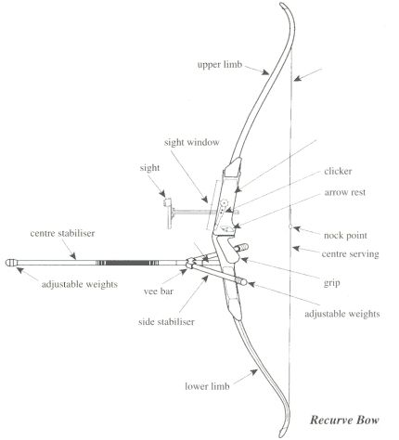
- Recurve - Recurve equipment is the classic archery style and is the only type permitted in the Olympic Games. In the recurve style, few technical devices are permitted to enhance accuracy, assuring that the archer’s strength and skill become the main factors that determine performance.

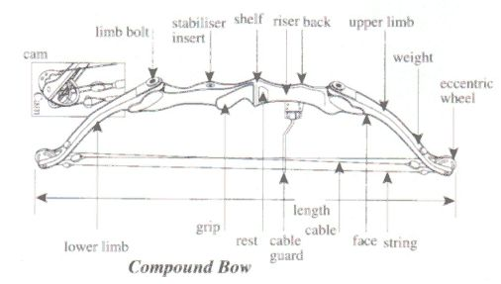
- Compound - Compound style equipment is much more technically sophisticated than recurve, with the bows employing wheels or “cams” at the tip of the limbs. Acting on a lever principle, these wheels allow an archer to draw and aim a bow with relative ease. Compound style shooting also permits the use of hand-held “triggers” for releasing the bow-string, and telescopic sights that increase accuracy.
The archer's choice of recurve or compound equipment is a personal preference.

III. Cost of Archery Equipment
Target archery equipment is high-tech, reliable, extremely safe, and accurate. Target archers DO NOT shoot arrows or attachments which are designed to cause injury.

Price wise, the equipment is roughly equivalent to new golf gear. A considerable second hand market for archery equipment exists within most archery clubs, with trade at prices typically 50%-75% of the original cost.
The following prices for new equipment should be taken as a guide only, as some variation can be expected from shop to shop.

- Bow - New bow prices range from around $200-$500 for quality introductory-level gear, up to $1500-$2000 for competitive equipment (such as used by international contenders).

- Arrows - Arrows made from aluminum or composites of aluminum and carbon range in price from $100-$500 per dozen. These prices are for fully constructed arrows, cut to size, with points, nocks, and feathers (or plastic “fletches”).

- Accessories – Accessories for the advanced archer may include a belt and hip quiver, locking case, finger tab/release aid, sight, and stabilizers, etc. Depending on an archer’s involvement and commitment to high level competition, these items can run from $20-$ 1500.

IV. Archery Tournaments
- Indoor - The program for a typical target archery indoor tournament might run something like this:

  - 30 arrows shot at a distance of 18 meters
  - break until the following day (though it is possible to pause only for lunch)
  - 30 arrows shot at a distance of 18 meters
Arrows are shot in sets of 3. A set of 3 arrows in target archery is called an “end.”
The scoring and retrieval of arrows takes places after each end. Ten consecutive ends, each shot at a three minute time duration, completes each of the distance sections.

- Outdoor - The program for a typical archery outdoor tournament might run something like this (this format is FITA regulation):

  - 36 arrows shot at a distance of 90/70 meters (men/women)
  - break for lunch
  - 36 arrows shot at a distance of 70/60 meters (men/women)
  - break until the following day
  - 36 arrows shot at a distance of 50 meters (men/women)
  - break for lunch
  - 36 arrows shot at a distance of 30 meters (men/women)

Arrows are shot in sets of 6 at the long distances and sets of 3 at the short distances.
The scoring and retrieval of arrows takes places after each end. 6 consecutive ends, each shot at a 3 or 4 minute time duration, completes each of the distance sections.

V. Shooting Control and Safety
NAA registered clubs take pride in their careful conduct. Special rules and procedures have been developed for the safe conduct of practices and tournaments - a care that has assured archery an extremely safe record as a sport. Although safety guidelines for the Sun Devil Archers are discussed in further detail in a later portion of this document, an outline of the rules and procedures governing safety and shooting control follows:

- Control of the practice or tournament is in the hands of a “Range Captain.” Archers must obey the instructions of the Range Captain at all times.

- Equipment inspections may be conducted before shooting commences. Archers may not take the field with equipment deemed unsafe by a judge or event organizer. Tight fitting clothing should be worn to prevent fouling by bowstrings. Long hair should be tied back for the same reason.

- A drawn bow must only be pointed towards the designated target and only then if it is intended to be shot.

- No person may go forward of the shooting line unless the Range Captain has signaled that it is safe to do so.

- Before each end archers must remain at or behind the designated waiting line. The signal to move to the shooting line is 2 blasts of a whistle.

- During the act of shooting an archer must have one foot wholly behind the shooting line, or both feet on the shooting line. Archers must exercise care during shooting to assure that their equipment at no time obstructs or interferes with the equipment of other competitors.

- When satisfied that the field is clear, the Range Captain signals the commencement of shooting for that end with a single blast of a whistle.

- After shooting each end, each archer must quietly vacate the shooting line and retire to a position behind the waiting line. The signal to cease shooting and retire to the waiting line is 2 whistle blasts.

- A time limit of 4 minutes for 6 arrows applies, unless the Range Captain has ascertained that all archers have retired beyond the waiting line before the 4 minutes have elapsed. Any arrow shot after the cessation whistle brings a penalty: the archer must forfeit the highest scoring arrow for that end.

- When the Range Captain has ascertained that all archers have retired beyond the waiting line, 3 whistle blasts are signaled to allow archers to proceed to the targets to score and recover their arrows. Archers score and collect their arrows simultaneously.

- An emergency or “danger” signal to cease shooting is 4 or more whistle blasts. All archers must immediately cease shooting and retire to the waiting line upon the emergency signal.

- Archers must not run to the target to collect arrows, and should look for arrows lodged in the ground short of the target (in order to avoid leg injuries when approaching the target).

- When drawing arrows from the target care must be taken to see that no person is in the path of the rear end of the arrow as it is removed.

- After each end, archers should carefully inspect their arrows for damage. Damaged arrows must be discarded.

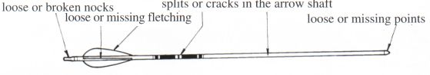

VI. Getting Started In Target Archery
The most important part of getting started in target archery is to obtain correctly fitting equipment. Each archer's natural eye dominance, strength threshold, draw length, and required arrow length and stiffness have to be worked out in advance in order to guarantee an equipment set-up that is sensible, safe, and comfortable to use.

VII. Qualified Coaching

The National Alliance for the Development of Archery (NADA) is a non-profit alliance of certified archery instructors. Its mission is to encourage qualified individuals to become certified instructors using course materials developed by the NAA, the governing body for US Olympic archery. Sun Devil Archery team members are Level 1 certified instructors, while each member of the program’s leadership maintains a minimum of a Level 2 rating.

Sun Devil Archery RANGE RULES

Archery is one of the safest sports we can do, but there are some precautions that need to be considered before, during and after shooting:

- A bow must not be loaded with an arrow unless standing on the “Shooting Line” and the signal to start shooting has been given.

- A loaded bow must only be pointed at the assigned target. It must not be pointed at another person.

- An arrow must not be shot straight up into the air.

- Archery equipment must be used in places that are especially set up for target practice - such as indoor and outdoor target ranges. Targets should be set up to insure that no one can be accidentally hit by a stray arrow.

- A cracked or bent arrow must never be shot.

- A person must never stand in the shooting lane forward of an archer about to shoot.

- While someone else is shooting, other’s eyes and minds should be kept alert for possible danger.

- Where possible danger exists, one must not shoot.

- At least one member of a group should always remain standing in front of the target while others are searching for arrows.

- When each student has finished shooting their arrows, they should stand back from the shooting line so the instructor or teacher can clearly see that they have finished.

- One must always keep to the marked path from each target to the next shooting stand.

- Only when everyone has finished shooting should the signal to move forward to collect the arrows be given.

- If an arrow or part of equipment is dropped in front of the shooting line while shooting is in progress, it can only be picked up after shooting has stopped.

- Walk forward to collect the arrows, never run.

- Always walk up to the side of the target butt, so as to not to accidentally walk into the rear of the arrows lodged in the target.

- One person at a time should withdraw their arrows from the target.

- One must always use a bow stringer for recurve bows. This will reduce the possibility of damage to the bow and injury to the person.

- One must check his/her bow for cracks or twisting. If you in doubt of your equipment’s safety, have it checked by a coach or instructor before continuing to shoot.

- When withdrawing arrows from the target, make sure no one is standing in front of the target or in the way of the withdrawn arrows. Withdrawing the arrows may require some force and the arrows may come out suddenly from the target butt and the rear end of the arrow could hit someone standing in front of the target.

- When carrying arrows, always hold them to the side.

- After each end, everyone must return to the shooting line and the range must be checked to make sure no one is behind the target butts or in the safety zone before the signal to commence shooting is given.

- If any person or animal (i.e. dog) enters the safety zone while shooting is in progress, the emergency signal must be given, and all shooting must stop immediately! Even if the bow is held at full draw and the signal is given, the arrow must not be released. The bow should be pointed at the ground and the bowstring let slowly forward. The arrow should be removed from the bow until the range is clear.

- The coach or instructor will keep a close watch not only on the students, but also on the archery range to ensure it remains clear of people.

Sun Devil Archery RISK ASSESSMENT

Activities usually carried out by the club:

- Archery Practice - daily
- Competition - Arizona and the US

Personal Safety

Hazard | Risk Factor | Risk management
Archer’s hair, clothing, jewellery, body piercings, badges, buttons etc. become entangled with string on release resulting in personal injury. | Moderate | Ensure archers tie back long hair and remove loose/dangling jewellery which might entangle with bow string. Instruct new archers in appropriate clothing for the sport.

Equipment Set-up and Use

Hazard | Risk Factor | Risk management
Limb bolts work loose resulting in bow coming apart in use. | Moderate | Instruct archers in correct assembly of equipment including limb assembly and stringing / de-stringing. Regularly (monthly) inspect limb bolts and nuts for signs of excess wear. Check novices’ bow setup before shooting.
Target stand mishandled. Target butt may fall on archer resulting in personal injury. | Moderate | Instruct archers in the handling of stands and butts. Instruct archers not to lift stands alone and in correct technique for mounting the butt on stand.
Target butt / stand not secured. Target butt may fall on archer resulting in personal injury or damage to arrows. | Moderate | Instruct archers in method for securing butts to stand / ground. Do not allow shooting to commence until all targets appropriately secured.
Archer’s arrows too short. Arrows may be drawn off the arrow rest and may be loosed into the bow hand. | Low | Check arrow length for all new archers using the prescribed technique. Issue only arrows of required minimum length. Do NOT allow archers to shoot if arrows of the required length are unavailable.
Use of inappropriate draw weight bow. | Moderate | Instruct beginners with light weight bows (18 - 20 lb @28"). Ensure archers purchasing own equipment receive appropriate advice.
New archers may mis-release the string resulting in the string striking the archers elbow / forearm. | High | Ensure all archers use appropriate arm protection and beginners are closely supervised. Ensure archers are instructed as to correct technique for positioning bow arm.
Risk from arrows in ground / target. Arrows which have fallen short of or behind the target may cause personal injury if walked / run into. Arrows in the target represent a hazard to approaching the target and may result in personal injury. | Moderate | Instruct archers in these hazards and of the importance of approaching the target with caution. Instruct new archers in the correct technique for drawing arrows from the butt. Do NOT allow anyone to run on the range or to wear open toed shoes. Ensure lost arrows are reported and every effort is made to locate them.
Bow string breaks while archer at full draw. String may strike archers head or arms resulting in personal injury. | Moderate | Regularly (weekly) inspect strings for wear. Check for worn or broken end servings and broken. Discard strings with broken strands and repair strings with worn servings.
Bow limb or riser fails while archer at full draw. Parts of limb may strike archer’s head or arms resulting in jury to the struck part. In extreme cases this may include damage to or loss of an eye or maxilo-facial fractures. | Moderate | Regularly inspect limbs for signs of cracks or splits. Warn new archers against "dry loosing" bows as this may promote early failure. Discard and replace limbs thought to be damaged or unsafe on inspection. Do NOT shoot lightweight carbon arrows from wooden bows, wooden arrows from high weight recurve, or any compound bows.
Worn or damaged arrow or part thereof fails during shot. Damaged nocks may result in arrow leaving bow unpredictably or result in a dry loose. | Low | After each end inspect arrows for loose or damaged nocks. Check for loose points. Replace any loose or damaged nocks or points. Examine arrows for cracks. Discard any arrows showing signs of structural damage - do NOT attempt to repair arrows showing signs of structural damage.
Release aid rope or other mechanical release failure. This may result in facial injury. | Low | At the beginning of each session/practice inspect release aid ropes for wear. Replace any showing significant wear. Instruct archers in the proper use of release aids and how to avoid triggering during the draw.

Control of Shooting

Hazard | Risk Factor | Risk management
Inadequate control of shooting may result in personal injury to an archer or spectator | Low | Shooting MUST always be under the control of an experienced archer acting as the Range Captain or a qualified Coach. All archers must understand that this person is in charge of the shoot and must obey his/her commands.
Incorrect range layout results in personal injury to spectators or archers. | Low | The range MUST be secure and laid out in accordance with the NAA Rules of shooting. Shooting must not begin if this is not the case. Spectators and participants must be advised where they may and may not stand while shooting is in progress.
Arrows inadvertently shot outside of safety area may result in personal injury to spectators or archers | Low | Archers must be made familiar with and adhere to NAA Rules of shooting. Any archer deemed by the Range Captain or Coach not to be doing so should be asked to leave the field. In particular archers must not be allowed to use any form of "high draw" and should be asked to ensure that the point of the arrow is not raised significantly above the nock.
A person or animal straying into the safety area may receive personal injury from arrow or other equipment projected towards the target | Low | Ensure that the range is laid out according to the NAA Rules of shooting and that the safety area is observable at all times. In particular ensure that access past the shooting line to indoor ranges is secured before shooting commences. The Range Captain AND Archers must remain vigilant and suspend shooting if the safety area is violated. People shall not be able to enter the shooting area without passing a suitable barrier warning that beyond which a danger exists. Ensure that spectators and those waiting to shoot remain behind the waiting line. Ensure all participants are familiar with commands to start and stop shooting. Do not allow anyone to cross the shoot line except when instructed to do so by the Range Captain.
Competitors / officials at risk from elements. When shooting outdoors, an archer or his/her equipment may be struck by lightning and electrocuted. | Low | Shooting should be suspended at the first sign of thunderstorms in the immediate vicinity and not resumed until it has passed.
Accident occurs while in vehicle travelling to a competition. | Moderate | Ensure that only registered drivers with safe records are responsible for transportation.
Related ARTICLES and STATISTICS



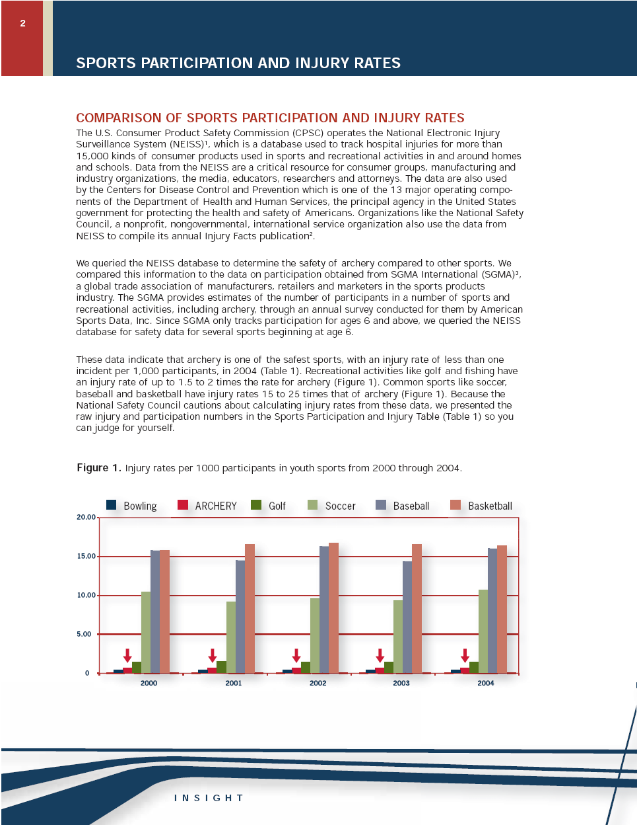



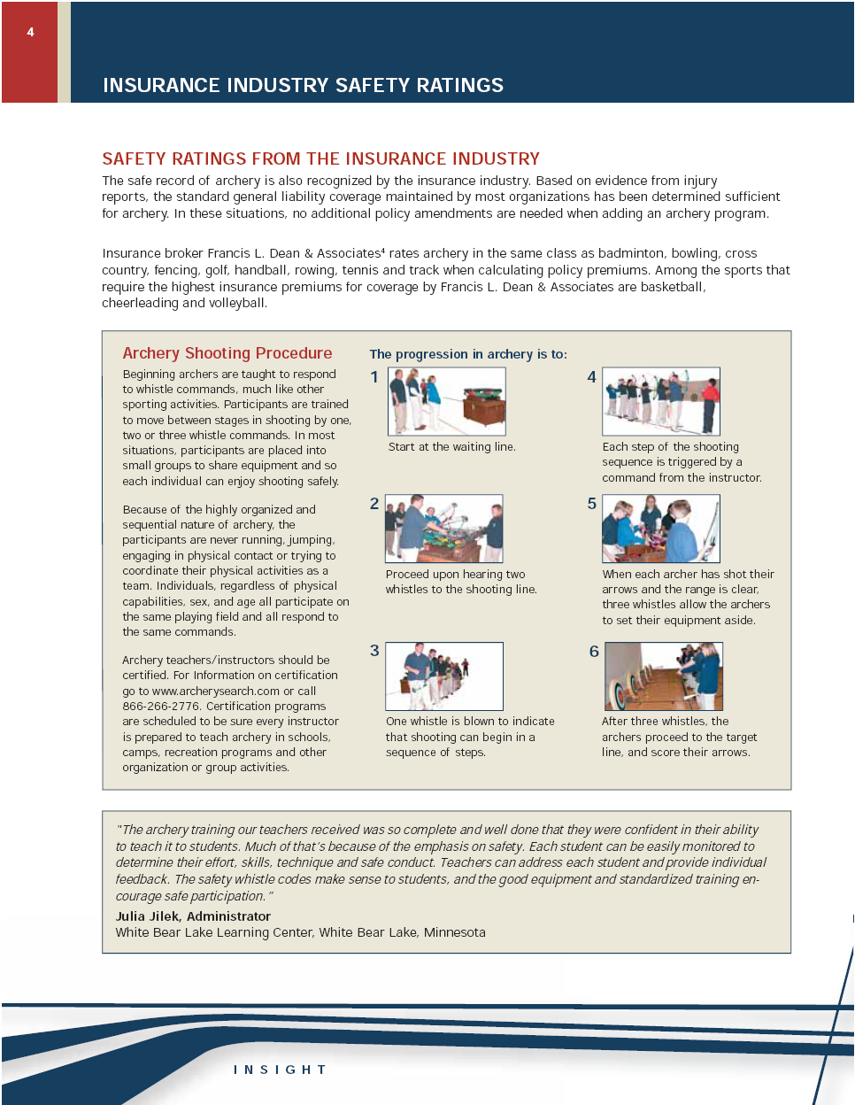

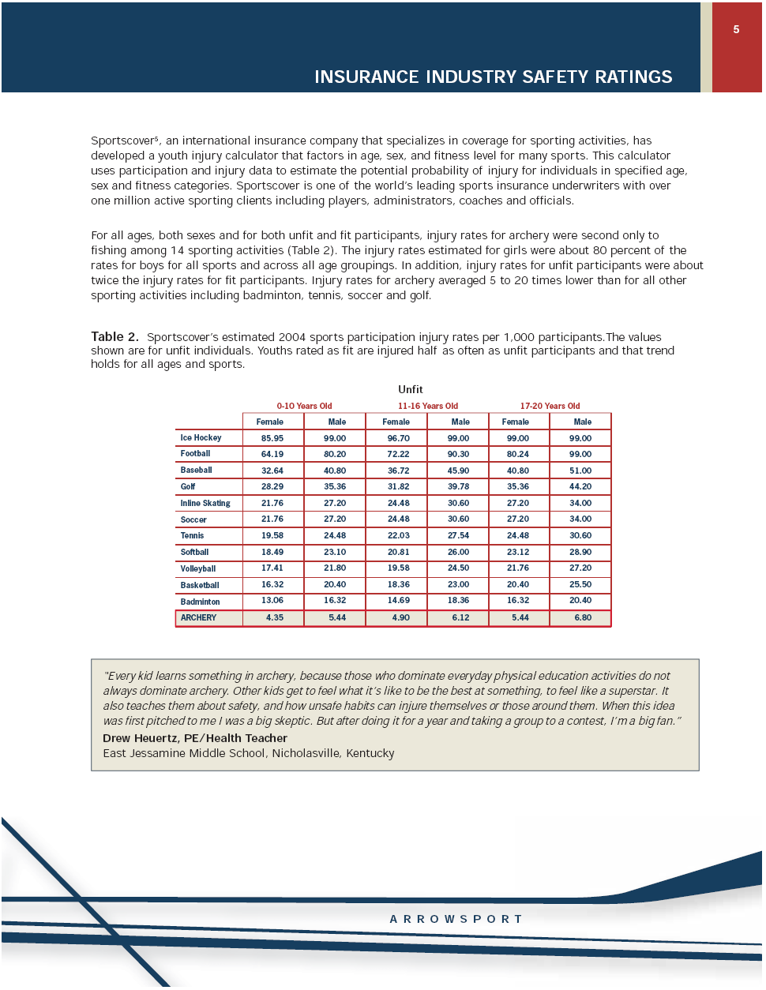

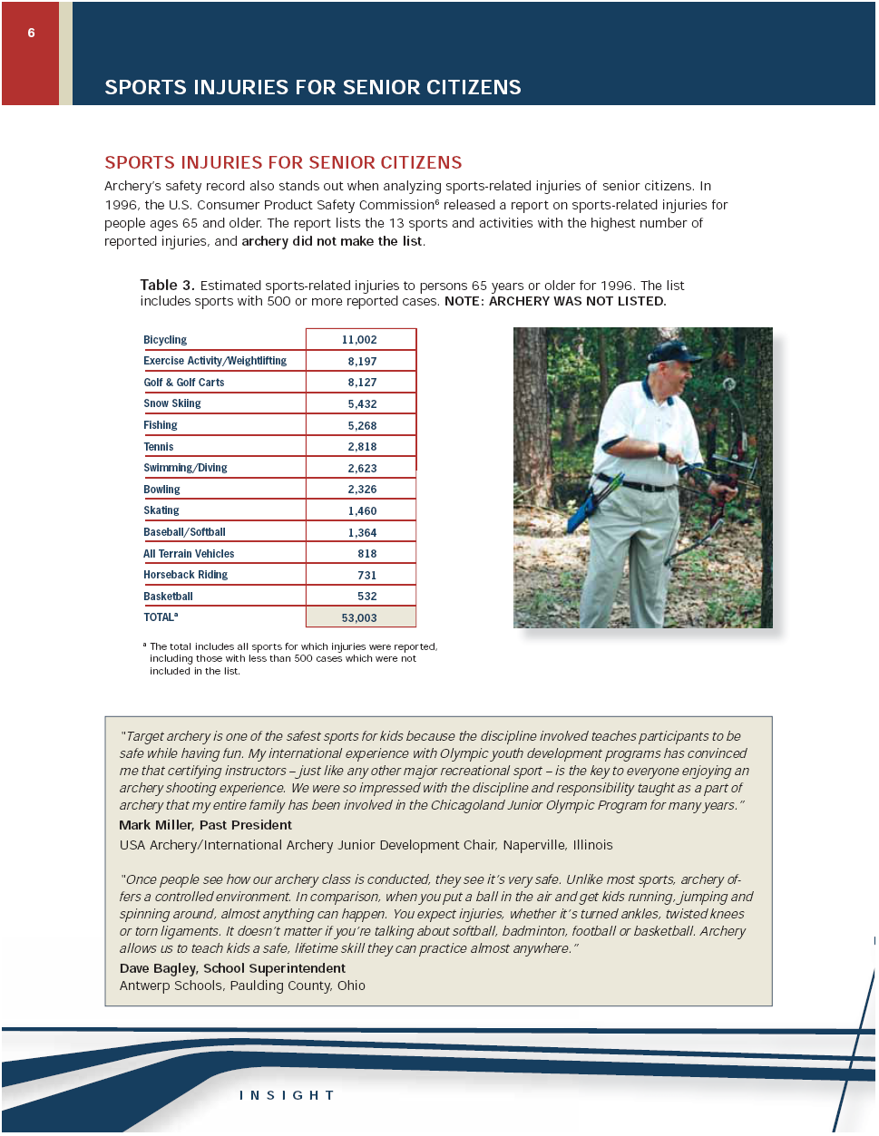

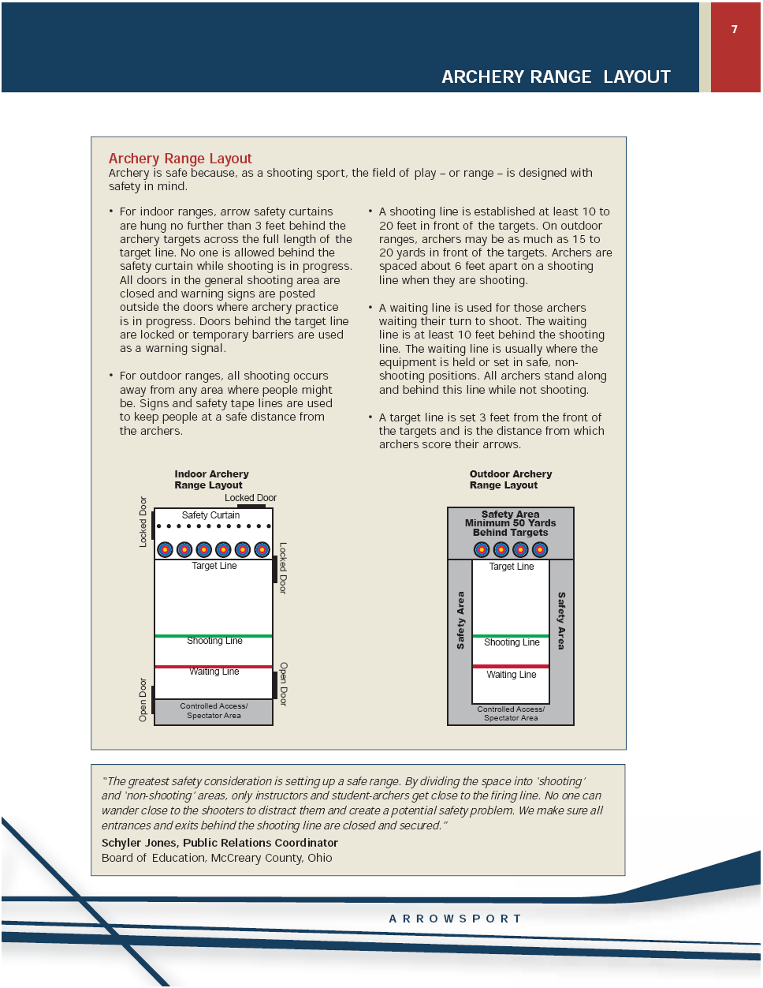



Why Archery is Safer Than Golf & Fishing
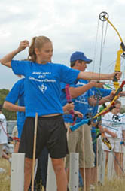
Why Archery is Safe for All
New "Insight" publication by ArrowSport provides testimonials and statistics that prove archery is a safe sport enjoyed by young and old, male and female.
Even as schools, municipalities and state wildlife agencies across the country expand archery programs and build new archery ranges, they're continually questioned about the sport's safety record. To better address those questions, ArrowSport now offers an 8-page, full-color "Insight" pamphlet titled, "Is Archery a Safe Sport? Yes!"
The "Insight" pamphlet provides independent research and firsthand testimonials from teachers, administrators and instructors that show archery is one of North America's safest sports. The pamphlet is available to schools, recreation departments, private groups and anyone else considering whether to offer archery in their curriculum or program, or include archery ranges as part of their facility.
"We've always known archery is fun and safe, whether you're in grade school or living in a retirement community," said Denise Parker, vice president of the Archery Trade Association. "We were so confident in that belief that we purposely sought independent research from the insurance industry, the Consumer Product Safety Commission, and the sporting goods industry to see where archery stacks up in terms of safety. No matter where we looked, the statistics exceeded our expectations. This pamphlet puts all those results into one comprehensive, easy-to-read publication."
Parker said the staff of ATA and its nonprofit foundation ArrowSport expect questions about safety every time a school or private group considers whether to offer archery. "You have to assume that almost everyone on a school board or rec committee will have little to no experience with archery, and that they'll ask safety questions," Parker said. "They're just doing their jobs. But after they review this information, they'll better understand why archery is one of the safest, most beneficial sports they can offer."
Among the information cited in ArrowSport's "Insight" publication are comparisons of injury rates per 1,000 youths participating in archery, bowling, golf, soccer, baseball and basketball. The injury statistics are gathered by the National Electronic Injury Surveillance System (NEISS), which is part of the U.S. Consumer Product Safety Commission (CPSC). Injury rates for soccer, baseball and basketball were 15 to 25 times greater than for archery. Further, golf and fishing produced 1.5 to 2 times as many injuries as archery.
Because archery is so safe, insurance companies rank it with other low-danger sports such as badminton, golf and tennis. "We have yet to hear of a school that had to take out additional liability insurance to include archery in their program," Parker said. "Archery's track record shows it's not a sport that concerns insurance companies."
Dave Bagley, school superintendent for Antwerp Schools in Ohio, explains why archery is so safe for all age groups: "Archery offers a controlled environment. In comparison, when you put a ball in the air and get kids running, jumping and spinning around, almost anything can happen. Archery allows us to teach a safe, lifetime skill kids can practice almost anywhere."
The "Insight" pamphlet also explains and illustrates how to safely set up indoor and outdoor archery ranges, and the six steps for safely conducting archery shooting lessons. As Gene Wilhoit, commissioner of Kentucky's Department of Education says, archery is safe because a well-run class follows specific procedures.
"Because we emphasize safety with our students, conduct training for all teachers, and adhere to standard procedures, we have a remarkable safety record," Wilhoit said. "Vigilant school districts are always concerned about liability issues, especially with sports and recreation activities. Archery consistently proves itself one of the safest sports taught in our public schools' physical education programs."
Copies of "Insight: Is Archery a Safe Sport? Yes!" are available from ArrowSport. Contact the foundation at (866) 266-2776; visit its web site, www.arrowsport.org email Kelly Kelly at kellykelly@archerytrade.org.
National Safety Council: Injury Facts 2004

The National Safety Council (NSC) was chartered by an act of Congress and is a nongovernmental, not-for-profit, public service organization. They publish "Injury Facts" each year, summarizing statistics about all sorts of injuries and accidents. In 185 pages, they lay out all sorts of injury and death statistics, and they compare the US numbers against countries around the world.

Sports participation and injuries from 2002 are available.

Archery (including hunting and target) is estimated to have had 4,200,000 US participants in 2002, with 4,306 ER-reported injuries (nearly all hunter related), a rate of 0.10252380952380952380952380952381 per cent. (0.1%)

Rates for other sports:
- Baseball: 15,600,000 with 178,668 injuries = 1.15%
- Basketball: 28,900,000 with 615,546 injuries = 2.13%
- Billiards: 35,300,000 with 6,235 injuries = 0.02%
- Football: 17,700,000 with 387,948 injuries = 2.19%
- Ice Hockey: 2,100,000 with 16,435 injuries = 0.78%
- Soccer: 14,500,000 with 173,519 injuries = 1.2%
If you multiply each percent by 10, you can get a ROUGH notion of comparisons. For every 1 person injured in archery and visiting an ER as a result, 21 (!) Americans visited an ER because of basketball, 22 due to football, 8 due to ice hockey, and America's pastime, baseball, delivered more than 11 people to the ER in 2002 for every 1 archer in an ER.

It is very difficult to derive many sound conclusions based on the emergency room documents involved in this study. Most serious presentations in ERs appear to be due to broadheads (stepping on them in a closet, for example, or simply putting them on to the shaft and slicing the finger), falling out of tree stands, while the severest injuries are from hunting-related accidents rather than target archery. Many less staid presentations are due to string slap (totally avoidable) on the arm. Some were of the "Darwin Award" category and a few were sadly unsupervised youth activities.

Compared to the usually practiced sports, one thing can be reliably deduced and that is the general safety of archery, compared to most all other sports. Proper coaching, especially of the complete novice, would probably have resulted in many of the string slaps and other simple injuries being avoided.

http://www.texasarchery.org/eletters/20050316.htm#article2 (modified for simplicity of reading)

Archery In Schools Program Launches Into Equality State
7/25/2003
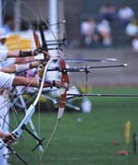
CASPER - Some Wyoming students will be on target this year with help from the Game and Fish Department. But first, their teachers need to aim in the right direction.

Twelve schools have been selected by the G&F to pilot the Wyoming’s first Archery in the Schools Program. Co-created by the Kentucky Departments’ of Education and Fish and Wildlife Resources, the curriculum covers archery history, safety, technique, mental concentration and self-improvement. More importantly, the program promotes confidence and self-worth because the sport is accessible to all students, no matter their age, gender or athletic ability. Before implementing the two-week course this fall, 18 teachers, as well as a number of G&F personnel and Hunting and Fishing Heritage Expo volunteers, will train Aug. 3-5 in Casper.

“Archery is really and truly a way of life,” said Brent Manning, G&F director and avid archer. “It is an alternative to the bad things young people can get involved in. “So when a very good friend of mine, the director of Kentucky’s Department of Fish and Wildlife Resources, talked to me about the program and showed me how successful it had been, I wanted to share it with Wyoming’s youth.”

The teachers will be undergoing the National Archery Association Level I and Level II training program at Roosevelt High School in Casper. The workshop stresses safety and technique, with a special emphasis placed on teaching the new archer. The G&F feels especially fortunate to recruit Rod White, Olympic archery gold medallist in 2000 and bronze medallist in 1996, as one of the lead instructors.

In addition, the teachers will be receiving their Archery in the Schools program “kits.” The equipment, from the bows to the Kevlar arrow-resistant nets, is state-of-the art and designed to fit every student. Archery manufacturer Brennan Industries and the G&F are splitting the $4,800 cost of the program kits needed for each school. The equipment, which includes 10 right-handed and one left-handed compound bows, will be on permanent loan to the school as long as they participate in the program.

Although certificating the teachers will not relieve the school’s liability, it does give the instructor the backing of the National Archery Association, especially if safety issues arise, though it should be noted there has never been a documented archery injury in a school program.

The pilot high schools are Buffalo, Campbell County, Cheyenne Central and East, Powell, Shoshoni, Wind River and Roosevelt in Casper. Pilot junior high/middle schools are Cody, Dubois, Rock Springs and Twin Spruce in Gillette.

Archery has been a big draw at the Hunting and Fishing Heritage Expo, and Expo volunteers will also be completing archery instruction certification. That way, students and families attending the Expo will also benefit from the new Archery in the Schools program.

For more information about the Archery in the Schools program, which is part of the G&F’s Outdoor Recreation Education Opportunities Program or OREO, contact Patty Stevens at (307) 777-4552
http://gf.state.wy.us/services/news/pressreleases/03/07/25/030725_2.asp
Schools hit bull's-eye with archery program
By Steve McClain Staff Writer

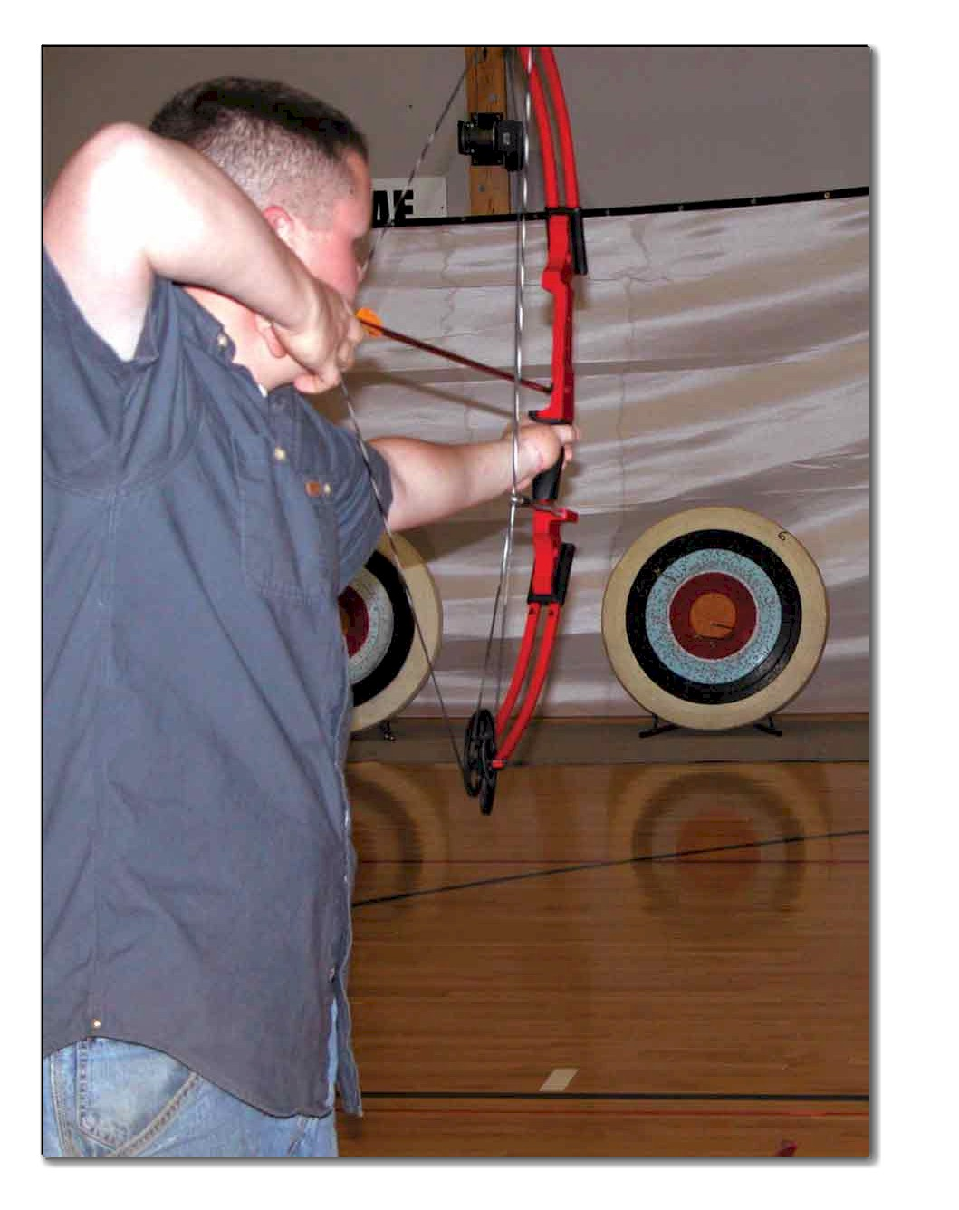
A whistle blows and students step to the line, bows drawn and prepared to fire their arrows. As the arrows zip toward the Olympic-style targets, students know how fast the arrows travel, know archery safety and history.

It's part of the National Archery in Schools program that safely teaches archery in more than 200 public schools across the state. Organizers with the Kentucky Departments of Education and Fish and Wildlife Resources hail the program as not just another P.E. unit, but an activity that incorporates core content areas and taps students' desire to compete regardless of athletic ability.

"I won first place in the elementary division last year, and once I did well, I decided to do it again and see how I'd do," said Elliott County seventh-grader Whitney Fannin, who recently placed third in the middle school division at a national tournament.

Educational, physical benefits

Roy Grimes, an assistant commissioner with the Kentucky Department of Fish and Wildlife and an avid archer who helped launch the program, and Connie Shackelford, Health and Physical Education Consultant with the Department of Education's curriculum division, helped develop a curriculum focusing on Olympic-style target archery that was KERA-compliant.

"Language arts, math, science and arts and humanities are incorporated into the curriculum," Shackelford said. "Students calculate velocity and graph the path of the arrows, learn the history of archery, safety procedures and there are prompts for portfolio pieces." "KDE has provided us with some units that can be incorporated into our classrooms, dealing with physics and math," said Trigg County superintendent Tim McGinnis. "When you can take a child's interest and use that to make a connection with the core content, that's tremendous."

The controlled atmosphere in class eases any concerns of safety. Students follow whistle commands that signal when they can approach the shooting line, draw their bow, fire and retrieve their arrows. Grimes said there has never been an archery accident at school in the country, and Shackelford added studies show the only safer sport is bowling.

"We've heard that it is so controlled, that core content teachers who have these students after P.E. say they are better behaved and ready for direction," Grimes said.

People may not think of archery as a rigorous physical activity, but Shackelford said it is amazing how much core strength is needed, and it also builds muscle endurance, flexibility and breathing techniques that can transfer to other sports.

"We were looking for something to get more students involved, especially if those students weren't in good shape to play basketball," said Denise Boggs, a teacher at Isonville Elementary in Elliott County who was a professional archer for 10 years. "We needed something to get them active."

Corbin board member and physical therapist Lisa Cleary said the program has been a real asset.
"It helps improve upper body strength, grip strength, eye-hand coordination, dexterity and mental concentration," she said. "I think it is a great athletic alternative and provides a different type of exercise."
"I've got students wanting to come to P.E. now and not wanting out of it," said Corbin Middle P.E. teacher Patty Smith.

Grimes said schools interested in starting the archery program should contact him, identify a teacher to undergo training, then purchase a standard equipment kit - 11 bows, five dozen arrows, five Olympic-style targets, a backstop net, eight floor quivers, a repair kit and an equipment box. Kentucky schools pay $2,033, while out-of-state schools pay $2,700. Donations and contributions from the archery industry cut schools' costs.

Anyone can participate

When the P.E. units were being developed, the hope was that students of any size or skill level would succeed, and teachers say that is happening.

"Kids who couldn't play ball are shooting bows," said Kenneth Roark, principal and coach at Leatherwood Elementary in Perry County. "I can think of several kids who don't play ball, but went to the national tournament. They wouldn't be involved in any extracurricular activity if not for archery."

"Everyone has equal opportunity in archery competition. You can be a big kid or a little kid," said Patrick Crawley, a math teacher and archery coach at Cumberland County.

School board members where the program is in place praise it for including more than the stereotypical athlete.

"It gives students that otherwise wouldn't have the opportunity to do this to get interested. It gives them a sense of belonging with other students," said Cumberland County board member Lovell Grider, whose daughter Whitney participates. "I know I would have enjoyed something like this when I was at Cumberland County High."

"It fills a niche and benefits those younger kids that maybe don't want to play basketball," said Elliott County board member Joe Salyers.

Organizers have also found special needs students do well in archery.

"A lot of times, special education students can't focus on one thing for a long time," said Tina Davis, athletic director at Trigg County and coach of the district's ArrowCats. "I think it's helped them to understand the importance of focus."

"Archery is fun. It shows you how to concentrate your mind," said J.J. White, a Trigg County seventh-grade special education student. "I remember that I've got to concentrate at home and keep my grades up in As and Bs."

Grimes said these students are perfect examples of who the program was geared for.

"The subtitle of the program was, 'Because not everyone can dunk the ball,'" he said. "You don't have to be fast, strong or tall to be good at archery. We've also had students in wheelchairs and with special needs that do well."

Aiming for the future

When Grimes first approached KDE on starting the archery program, the idea was to start another high school sport. However, Education Commissioner Gene Wilhoit suggested starting the program at the middle school level.

"The smartest thing we've done in this program is say 'Yes' to that," said Grimes. "We changed our focus from high school sports, which would have been a very elite group of archers, probably existing archers."

Grimes said the goal of archery becoming a high school sport sanctioned by the Kentucky High School Athletic Association is still on the horizon. "When we get 20 percent of the high schools indicating an interest, KHSAA will consider sanctioning it. We're within five schools of that, and I think by summer we'll be having those discussions."

More importantly, the students are learning a lifetime sport.

"I played football earlier, but my coach told me I'd have to pick between football and shooting, and I picked shooting," said Graham Cofield, a Trigg County sophomore who won a national championship at the recent tournament in Louisville.

"The number one goal for P.E. teachers is to provide kids opportunities for a lifetime," said Greg Adkins, an elementary P.E. teacher and archery coach at Elliott County. "This is something I can see these kids be involved in 20, 30 years from now."

Brad Hughes, KSBA's communications director, contributed to this article.
http://www.ksba.org/KSA0504%20archery.htm

Southern California bans bowhunters
Recent politicking in Burbank and Imperial Beach has raised the ire of fans of bows and arrows
By James A. Swan, Ph.D. Author "In Defense of Hunting"

In sunny San Diego, for decades, archers have been allowed to bowfish for sharks and rays from the pier or shore at Imperial Beach.

And it is thought there never has been a bowhunting-related injury to any of the more than 2 million-plus swimmers surfers or onlookers that visit the beach yearly.

Nonetheless, in early July the City Council passed an ordinance banning bowfishing at Imperial Beach.
 | “ | There is still the potential for  an accident. … It just boils down  to acting in a reasonably concerned manner. ”
 |  | — A Burbank City Council member, responding to the fact there have been no bowhunting accidents in area where a bowhunting ban recently was enacted
Admittedly an arrow could injure a surfer, but archers who wanted to bowfish at Imperial Beach were required to pass a safety course and obtain a certificate. They also were prohibited from bowfishing during the daytime in the summer. And, swimmers and surfers were not allowed within 20 feet from the pier.

If the city fathers wanted to reduce risks, what about those surfers crashing into swimmers, or each other? Recent risk assessment research has concluded that water kills a child every 8 minutes. Maybe the ocean should be banned to make the beach really safe.

A second blow to bowhunting in Southern California was recently struck by the city of Burbank. You may think of Burbank as the home of Walt Disney, Warner Brothers, Columbia, NBC studios and the Griffith Park Zoo, but on the northeast side of the city lie the Verdugo Mountains that rise to 1,000 feet.

At more 7 miles long and 3 miles wide at their widest part, the Verdugos are part of the San Gabriel Mountains and home to some 500 deer, along with numerous rabbits, quail and coyotes, which, until this spring, have been legal game for archers.

Last fall some hikers got upset about seeing bowhunters in the Verdugos. Their complaints led to the passage of Burbank City Ordinance 3616, which forbids anyone "but a peace officer or animal control officer" acting in the line of duty from shooting arrows in the city limits — except at public and private archery ranges, of which there are none.

Admitting that there have been no bowhunting accidents in the history of Burbank, one city council member explained the reason for the ban: " … There is still the potential for an accident. … It just boils down to acting in a reasonably concerned manner."

In terms of risk, archery is one of the safest of all sports. Accidents in competition are unheard of.

There are 6 million bowhunters nationwide. From 1993 to 1998, the last five years for which data is available, injuries per year have never been more than 20, and fatal injuries per year range from three to six. Most of these are people falling, especially out of treestands.

Contrast those stats with much more injury-prone golf, tennis, badminton, baseball, touch football and even ping pong, let alone trail biking or skateboarding, and then let's talk about the potential for an accident.
Burbank already has an existing ordinance that makes it illegal to shoot arrows within 250 feet of a road, trail or building. California's Fish and Game code outlaws shooting across roads or within 150 yards of a home, unless it is your own.

The trails in the Verdugo Mountains have growing numbers of speeding mountain bikes, which do cause accidents. Why not outlaw trail bikes and joggers who cause more accidents? Is safety the real issue, or is it hunting?

When the Burbank City Council passed anti-bowhunting measure this spring, they must have expected to receive bouquets from various anti-hunting and anti-weapons groups. What they got was a delegation of angry bowhunters, headed by Craig Fritz, a vice president of California Bowman Hunters, and Curtis Herrmann, state director of National Bowhunter Education Foundation, with backing from the California Department of Fish and Game. The DFG asserts Burbank is interfering with the state's constitutionally guaranteed right to manage wildlife, including setting hunting seasons.

Initially, Burbank did not even file an environmental impact statement on the proposed law. They city elders felt such a decision could have no significant impact on the environment, and thus was exempt from review under the California Environmental Quality Act. The bowhunters and California DFG quickly challenged that.

For many years bowhunting has been the primary way to manage wildlife in the Verdugo Mountains, especially the deer herd, which ventures into residential areas to forage, wanders onto highways, attracts mountain lions and carries Lyme disease. Bowhunters also have helped control the local coyote population that feeds not only on young deer, but cats and dogs — and represents a threat to young children.
Realizing the error in their ways, Burbank conducted an Environmental Impact Study, which concluded that banning bowhunting in the city limits would not have any environmental consequences. The Council accepted the Negative Declaration on May 20 by a vote of 5-0.

The California DFG has previously contested situations where a local government tried to take over wildlife management without the state's permission, and the state has prevailed. Imagine the crazy-quilt pattern of wildlife management that would crop up if every political jurisdiction could make up its own wildlife laws.
Methods of urban wildlife control also are in question here. Despite what the Burbank Environmental Impact Study may claim, if you stop hunting in an area, animal behavior will change, populations will grow unless something else is done to control them, damages will occur and there will be more human-animal encounters — both positive and negative.

In many areas, including southern California, coyotes are replacing raccoons as the nightly marauders of garbage cans. Raccoons can spread rabies, as can coyotes. Coyote attacks on people are relatively rare, but growing in California. If coyotes lose their fear of humans, they can become brazen. One of my neighbors had a coyote walk into his kitchen, where his toddler was sitting in a high chair eating.

If coyotes do attack, children could be a target; but pets are tops on the menu. Friends in L.A. speak of brazen coyotes stalking cats and dogs in broad daylight and within sight of Disneyland.

You can trap or poison coyotes when they move into suburban areas, but the cheapest and safest approach is bowhunting. It not only reduces population size but restores the animals' wariness of people, which has been normal for as long as humans have been around.

All across America, communities are choosing to manage skyrocketing deer populations in urban areas with bowhunting.

While the Burbank city fathers don't want bowhunters in the their hills, in Milwaukee archery is used to control herds of deer, while other recreational activities continue.

Typically, urban bowhunters pass a special class and pay for insurance, as well as buy a hunting license.
California uses bowhunting to reduce deer and wild pigs on some parklands, such as the Lake Sonoma Recreation Area.

Animal rights activists, of course, don't like bowhunting, let alone its use for urban wildlife control. They advocate contraceptives administered through food — or darts or biobullets shot into does at least once a year.

The U.S. Sportsmen's Alliance recently conducted a survey of the 50 state wildlife agencies on the use of birth control for urban deer herd control. Eighteen birth-control projects aimed at deer have been completed or are underway in California, Connecticut, Illinois, Maryland, Minnesota, New Hampshire, New Jersey, New York, Ohio, Pennsylvania, Virginia and Wisconsin. Statistics show only 513 deer were treated during the studies.

The cost was $1,509,739, or an average of $2,943 per deer.

Other towns have employed sharpshooters to thin deer herds. The cost per deer runs from about $100 to almost $500. Trapping and relocating deer costs about $400 an animal, and up to 60 percent perish in transport or soon thereafter.

The Wildlife Society and the National Bowhunter Education Foundation have done considerable research on how to create a safe, economic and successful urban deer control program using bowhunting. Burbank has chosen otherwise.

Northern Californians like to think of themselves are somewhat more enlightened than downstaters.
In San Francisco's Golden Gate Park, there is a large outdoor archery range, which is free and open to all. Nearby you can rent equipment, if you don't have your own. There are no security guards or range masters present. They trust people. Accidents are unheard of.

To the point
Stanford Archery Program ranked ninth in nation

By Katie Bearman
Wednesday, April 14, 2004
At this very moment, a few talented Stanford students walking around campus have officially achieved Porn Star status.

Sorry to disappoint you, but these men and women are not actually popular figures in the sex entertainment industry. Rather, they are members of the thriving Stanford Archery Program. Stanford archers refer to their teammates as “Porn Stars” if they have, during the course of a single round, managed to hit three arrows in the innermost ring of the target, thus scoring an “X.”
“Contrary to popular opinion, this is actually quite hard,” said senior Helen Cheng, president of the Stanford Archery Program.
Many are unaware that an archery program exists on campus. Indeed, when asked what she thought of this program, sophomore Teresa Davis remarked, “Stanford has archery?”
Davis’ reaction is understandable. Archery is not a varsity sport at Stanford and therefore receives less publicity and funding than teams. Additionally, the Stanford Archery Program is relatively new. It was founded two years ago by junior David Lu and computer science graduate student Keith Coleman. Coleman had shot competitively prior to college, and, according to Cheng, Lu was interested in starting the club because he “wanted to shoot at things, but in a safe and structured way, of course.”
The fact that there are students here who like to “shoot at things” presents significant concern to junior Dave Singh, who commented that “Stanford Archery poses potential threats to the entire Stanford community.”
Don’t worry, Dave. Everyone who comes to shoot on the range must complete a safety instruction class, because safety is one of the team’s top priorities. Additionally, the perimeter of the range is roped off and follows, to a tee, the protective guidelines enforced by the National Archery Association, or NAA.
So esteemed is the archery program for its safety and excellence, in fact, that parents from all over the Bay Area send their young children to participate in Junior Olympic Archery Development, or JOAD — a course instructed every weekend by Stanford Archery team members.
Each Stanford archer is certified as a Level II instructor. Additionally, during the past two quarters, the archery squad has helped out at a Girl Scout camp, held an athletic camp for kids and hosted a benefit shoot. Stanford archers place great importance on offering exciting athletic opportunities for people both on and off campus.
“The Stanford Archery Program is called a program and not a team because we provide so much for the community,” Cheng said. “One of our express purposes is for other people to learn about archery, which is why we have so many community programs.”
While upholding exhaustive efforts to plan events for non-team members, the Stanford archers also practice tirelessly in preparation for their own tournaments. They compete at large national events against universities in which archery is a varsity sport.
Although they often must enter tournaments without a full team, they have placed very well at these events. Currently, the Stanford Archery Program is ranked ninth in the nation and first in the Western region.
Individual members of the Archery Program have also acquired impressive honors. Cheng, for instance, won a gold medal at the 2003 Pacific Coast Championships in the collegiate women’s recurve division. When one considers the Program’s practice schedule, these results are not surprising.
“Just this weekend, the team woke up at 8 a.m. on both Saturday and Sunday for intensive training to prepare for our upcoming tournament season. I spent five hours shooting on Saturday and nine hours on Sunday,” Cheng said. “Normally, we train six days per week.”
Cheng and her teammates take pride in their dedication and accomplishments.
“The amazing thing is that all of this is self-motivated, because we’re not a varsity sport,” she said.
Self-motivated, indeed. According to Cheng, members of the Stanford Archery Program include 19 men and women who “take 20 units of classes, are incredibly involved with other clubs and sports, hold jobs, do research, participate in Greek life and volunteer.”
The students in the Archery Program also attribute much of their success to their coach, Sheri Rhodes, who is the current coach of the United States Olympic Archery team.
“Rhodes is incredible, and we are extremely lucky to have her helping us,” Cheng said.
The Stanford Archers work very hard to raise enough funds to pay Rhodes as well as buy adequate equipment, hold tournaments and travel to competitions. Besides receiving some financial aid from the ASSU, members of the Stanford Archery Program teach beginner and other private lessons to earn extra money. Their participation in the JOAD program also brings in funds. Still, the Stanford Archery Program encounters many difficulties.
“We definitely face the challenge of wanting to do more and not having the manpower to do it,” Cheng said.
As the increasingly beautiful spring weather hits campus, Stanford students will have more opportunities to see the Stanford Archery Program in action. With the help of Economics professor and avid archer Steve Tadelis, the program has launched a student-initiated archery course this quarter.
Additionally, Stanford will be hosting the West Regional Intercollegiate Archery Championships. The tournament will take place on Roble Field, April 23-25, from 8 a.m. to 3 p.m. Recognized by the NAA, this event will include about 50 archers representing several universities.
The Stanford Archery Program is always enthusiastic to take in new members. One need not have archery experience to participate; there are practices for beginners, and the Archery Program provides equipment for those who want to learn how to shoot. Students who join the team will be in good company.
http://daily.stanford.edu/tempo?page=content&id=13750&repository=0001_article

Other ARCHERY Quotes and Notes
Archery at ASU
The sport of archery has a proud tradition at ASU. It began in the early 1960’s as a club sport and later moved into the realm of intercollegiate athletics. Archery ceased to be an athletic department sponsored sport at ASU in the early 1990’s. Until that point, the program had won more national titles (men's archery 15 times, women's archery 21 times, and mixed archery 20 times) than any other athletic group at ASU while additionally boasting numerous World and Olympic team members and medalists.
Throughout ASU Archery’s extended history, team archers were able to practice and store equipment on-campus. Since 1962, there have been no reports at ASU of injuries or misconduct involving officially sanctioned archery tournaments, practices, or team members.

For more information on Sun Devil Archery at ASU, please see: www.sundevilarchery.com

How safe are youth shooting sports?

The National Youth Sports Safety Foundation released a study of youth sports deaths for the years 1984-1988. The study identified 276 deaths in 14 different youth sports. Numbers ranged from a high of 69 deaths in baseball and 63 in football down to a low of 1 in volleyball. No deaths were attributed to youth target shooting activities. All statistics support the conclusion that archery, under the direction of responsible and capable adult leaders, are among the safest activities available to young people.

Archery in the Schools Program (AIS)

This program is designed to introduce Olympic-style archery into middle schools throughout Arizona. The program provides middle school P.E. programs with training, equipment and curriculum, to introduce youth to archery. For more information, contact Anthony Chavez at 602-789-3395.
http://www.azgfd.gov/outdoor_recreation/basf_classes.shtml

Archery Statistics:

1) 1998 Statistics: 39 sports were monitored by the NEISS (National Injury Surveillance System). Basketball came in first with 631,189 injuries, baseball with 180,582 injuries, and football with 355,247. Archery came in with the least.

2) Alister Taylor, a writer for the Nock-Nock (an archery magazine), noted that when she discussed the liability rates for sports with industry officials, they pointed out that archery is the sport that the insurance industry considers to be the safest and therefore has the lowest premiums.

From Michael Rael, UCLA

At UCLA we have a bin (like the ones of the back of a Mack truck) that we store all the club equipment in. It's kept locked when no one's practicing and all the club officers hold a key to the bin.
Club members are allowed to keep their personal equipment or club equipment that is reserved for them in their dorm rooms or apartments. UCLA Housing has given us trouble over this fact more than once because of UCLA's no weapons on campus rule - even though CA state says that a bows and arrows are not weapons.
We have never had an incident where anyone hurt themselves or someone else with their archery equipment outside of practice and the worst we've had during practice is someone getting poked with the back end of the arrow when someone else was pulling it out of the target.

From Robert Pian, AZ JOAD and Collegiate Archery

Risk is directly related to attitude.

On sites, the leadership and tolerance of inappropriate behavior has a direct relationship overall project quality and safety.

What Sun Devil Archery has in place is a commitment to NAA instructor certification of its leadership and the lessons learned by hosting tournaments frequently that teach the club responsibility and safety procedures.

Rules are only as good as the people that abide by them. Sun Devil Archery has the people and program to exceed safety expectations.

Bob Pian
Arizona Junior and Collegiate Archery
8681 East Via De Negocio
Scottsdale, AZ 85258

azjoad@cox.net
Phone 602-228-0465
Fax 480-991-2623

From Frank Thomas, Texas A&M

We run all our programs through Rec Sport’s sport club organization. Technically, weapons aren’t allowed in dorms but as long as we don’t take them out of their case or put the recurves together they usually let us slide. Note your insurance is provided by the NAA when you are a collegiate club.
-- Frank Thomas
Associate Department Head and Chair
Physical Education Activity Program
Department of Health and Kinesiology
Texas A&M University
979-845-7430

From Lloyd Brown, 2-time U.S. Olympic coach, NAA Director, and NADA Coordinator

In the West, we have programs at Stanford, UCLA, and Biola University. Cal State Long Beach also has a program. The College Division has never had an accident since they started in 1967 or something like that.

From Tina Blake, Embry-Riddle

I have shot archery in both high school and college competitions and have never seen or heard of an accident within my ten years of competition.

From Rita Nicholson, Accordia Insurance (NAA insurance provider)

We at Accordia can tell you that in the past five years we have not had any losses in archery. This is considered a low risk sport.

ASU and ARS POLICIES

Effective: 11/1/1990 | Revised: 6/15/2005
DPS 201–05: Weapons, Explosives, and Fireworks
Purpose
To state prohibitions regarding use and possession of weapons, explosives, and fireworks and to describe required reporting of violations
Sources
Arizona Revised Statutes §§ 13–2911; 13–3101; 13–3102 (A) (10) to 13–3103
Arizona Board of Regents Policy Manual - 5-308
Policy
Use, possession, display, or storage of any weapon, explosive device, or fireworks is prohibited on all land and buildings owned, leased, or under the control of Arizona State University or its affiliated or related entities, in all ASU residential facilities (whether managed by ASU or another entity), in all ASU vehicles, and at all ASU or ASU affiliate sponsored events and activities. ASU students and employees are required to report violations and suspected violations of this policy to ASU DPS immediately.
In addition to any sanctions available under applicable law, violations of this policy by ASU students are subject to sanctions under the ABOR Student Code of Conduct, and violations of this policy by ASU employees are subject to sanctions under ABOR and ASU policies governing employee conduct.
Exceptions
- a certified peace officer performing his or her official duties
- weapons used in authorized academic programs for which prior approval has been obtained from the director of ASU DPS or the director’s authorized representative
and
- any other activity that has been given prior written approval by the director of ASU DPS or the director’s designated representative.
Definitions
Explosive
Any explosive device or substance, including dynamite, nitroglycerin, black powder, or other similar explosive material including plastic explosives; any breakable container that contains a flammable liquid with a flash point of 150° F or less and has a wick or similar device capable of being ignited.
Fireworks
Any fireworks, fire crackers, sparklers, rockets, or any propellant-activated device whose intended purpose is primarily for illumination.
Weapon
Any object or substance designed to inflict a wound, cause injury, or incapacitate, including, without limitation, all firearms, BB guns, air guns, pellet guns, switchblade knives, knives with blades five or more inches long, and chemicals such as Mace, tear gas, or oleoresin capsicum, but excluding normally available over-the-counter self-defense chemical repellents. Chemical repellents labeled “for police use only” or “for law enforcement use only” may not be possessed by the general public.
Procedure
ASU students and employees are required to report violations and suspected violations of this policy to ASU DPS by telephone at 480/965–3456. If the incident involves an immediate threat to life or property, dial 911.
Cross-Reference
For an additional prohibition on weapons and explosives on campus, see the Staff Personnel Policies and Procedures Manual (SPP): SPP 801, “Employee Conduct and Work Rules”

ARS 13-2911
Interference with or disruption of an educational institution; violation; classification; definitions

A. A person commits interference with or disruption of an educational institution by doing any of the following:
1. Intentionally, knowingly or recklessly interfering with or disrupting the normal operations of an educational institution by either:
(a) Threatening to cause physical injury to any employee or student of an educational institution or any person on the property of an educational institution.
(b) Threatening to cause damage to any educational institution, the property of any educational institution or the property of any employee or student of an educational institution.
2. Intentionally or knowingly entering or remaining on the property of any educational institution for the purpose of interfering with the lawful use of the property or in any manner as to deny or interfere with the lawful use of the property by others.
3. Intentionally or knowingly refusing to obey a lawful order given pursuant to subsection C of this section.
B. To constitute a violation of this section, the acts that are prohibited by subsection A, paragraph 1 of this section are not required to be directed at a specific individual, a specific educational institution or any specific property of an educational institution.
C. The chief administrative officer of an educational institution or an officer or employee designated by the chief administrative officer to maintain order may order a person to leave the property of the educational institution if the officer or employee has reasonable grounds to believe either that:
1. Any person or persons are committing any act that interferes with or disrupts the lawful use of the property by others at the educational institution.
2. Any person has entered on the property of an educational institution for the purpose of committing any act that interferes with or disrupts the lawful use of the property by others at the educational institution.
D. The appropriate governing board of every educational institution shall adopt rules pursuant to title 41, chapter 6 for the maintenance of public order on all property of any educational institution under its jurisdiction that is used for educational purposes and shall provide a program for the enforcement of its rules. The rules shall govern the conduct of students, faculty and other staff and all members of the public while on the property of the educational institution. Penalties for violations of the rules shall be clearly set forth and enforced. Penalties shall include provisions for the ejection of a violator from the property and, in the case of a student, faculty member or other staff violator, the violator's suspension or expulsion or any other appropriate disciplinary action. A governing board shall amend its rules as necessary to ensure the maintenance of public order. Any deadly weapon, dangerous instrument or explosive that is used, displayed or possessed by a person in violation of a rule adopted pursuant to this subsection shall be forfeited and sold, destroyed or otherwise disposed of pursuant to chapter 39 of this title. This subsection does not do either of the following:
1. Preclude school districts from conducting approved gun safety programs on school campuses.
2. Apply to private universities, colleges, high schools or common schools or other private educational institutions.
E. An educational institution is not eligible to receive any state aid or assistance unless rules are adopted in accordance with this section.
F. This section does not prevent or limit the authority of the governing board of any educational institution to discharge any employee or expel, suspend or otherwise punish any student for any violation of its rules, even though the violation is unlawful under this chapter or is otherwise an offense.
G. This section may be enforced by any peace officer in this state wherever and whenever a violation occurs.
H. Restitution under sections 8-341, 8-345 and 13-603 applies to any financial loss that is suffered by a person or educational institution as a result of a violation of this section.
I. Interference with or disruption of an educational institution pursuant to subsection A, paragraph 1 of this section is a class 6 felony. Interference with or disruption of an educational institution pursuant to subsection A, paragraph 2 or 3 of this section is a class 1 misdemeanor.
J. For the purposes of this section:
1. "Educational institution" means, except as otherwise provided, any university, college, community college, high school or common school in this state.
2. "Governing board" means the body, whether appointed or elected, that has responsibility for the maintenance and government of an educational institution.
3. "Interference with or disruption of" includes any act that might reasonably lead to the evacuation or closure of any property of the educational institution or the postponement, cancellation or suspension of any class or other school activity. For the purposes of this paragraph, an actual evacuation, closure, postponement, cancellation or suspension is not required for the act to be considered an interference or disruption.
4. "Property of an educational institution" means all land, buildings and other facilities that are owned, operated or controlled by the governing board of an educational institution and that are devoted to educational purposes.

ARS 13-3101
Definitions

A. In this chapter, unless the context otherwise requires:
1. "Deadly weapon" means anything that is designed for lethal use. The term includes a firearm.
2. "Deface" means to remove, alter or destroy the manufacturer's serial number.
3. "Explosive" means any dynamite, nitroglycerine, black powder or other similar explosive material including plastic explosives. Explosive does not include ammunition or ammunition components such as primers, percussion caps, smokeless powder, black powder and black powder substitutes used for hand loading purposes.
4. "Firearm" means any loaded or unloaded handgun, pistol, revolver, rifle, shotgun or other weapon that will expel, is designed to expel or may readily be converted to expel a projectile by the action of an explosive. Firearm does not include a firearm in permanently inoperable condition.
5. "Occupied structure" means any building, object, vehicle, watercraft, aircraft or place with sides and a floor that is separately securable from any other structure attached to it, that is used for lodging, business, transportation, recreation or storage and in which one or more human beings either is or is likely to be present or so near as to be in equivalent danger at the time the discharge of a firearm occurs. Occupied structure includes any dwelling house, whether occupied, unoccupied or vacant.
6. "Prohibited possessor" means any person:
(a) Who has been found to constitute a danger to himself or to others pursuant to court order under section 36-540, and whose court ordered treatment has not been terminated by court order.
(b) Who has been convicted within or without this state of a felony or who has been adjudicated delinquent and whose civil right to possess or carry a gun or firearm has not been restored.
(c) Who is at the time of possession serving a term of imprisonment in any correctional or detention facility.
(d) Who is at the time of possession serving a term of probation pursuant to a conviction for a domestic violence offense as defined in section 13-3601 or a felony offense, parole, community supervision, work furlough, home arrest or release on any other basis or who is serving a term of probation or parole pursuant to the interstate compact under title 31, chapter 3, article 4.
(e) Who is a prohibited possessor under 18 United States Code 922(g)(5), except as provided by 18 United States Code 922(y).
7. "Prohibited weapon" means, but does not include fireworks imported, distributed or used in compliance with state laws or local ordinances, any propellant, propellant actuated devices or propellant actuated industrial tools that are manufactured, imported or distributed for their intended purposes or a device that is commercially manufactured primarily for the purpose of illumination, including any of the following:
(a) Explosive, incendiary or poison gas:
(i) Bomb.
(ii) Grenade.
(iii) Rocket having a propellant charge of more than four ounces.
(iv) Mine.
(b) Device that is designed, made or adapted to muffle the report of a firearm.
(c) Firearm that is capable of shooting more than one shot automatically, without manual reloading, by a single function of the trigger.
(d) Rifle with a barrel length of less than sixteen inches, or shotgun with a barrel length of less than eighteen inches, or any firearm that is made from a rifle or shotgun and that, as modified, has an overall length of less than twenty-six inches.
(e) Instrument, including a nunchaku, that consists of two or more sticks, clubs, bars or rods to be used as handles, connected by a rope, cord, wire or chain, in the design of a weapon used in connection with the practice of a system of self-defense.
(f) Breakable container that contains a flammable liquid with a flash point of one hundred fifty degrees Fahrenheit or less and that has a wick or similar device capable of being ignited.
(g) Chemical or combination of chemicals, compounds or materials, including dry ice, that are placed in a sealed or unsealed container for the purpose of generating a gas to cause a mechanical failure, rupture or bursting of the container.
(h) Combination of parts or materials that is designed and intended for use in making or converting a device into an item set forth in subdivision (a) or (f) of this paragraph.
B. The items set forth in subsection A, paragraph 7, subdivisions (a), (b), (c) and (d) of this section do not include any firearms or devices that are registered in the national firearms registry and transfer records of the United States treasury department or any firearm that has been classified as a curio or relic by the United States treasury department.

ARS 13-3102
Misconduct involving weapons; defenses; classification; definitions

A. A person commits misconduct involving weapons by knowingly:
1. Carrying a deadly weapon without a permit pursuant to section 13-3112 except a pocket knife concealed on his person; or
2. Carrying a deadly weapon without a permit pursuant to section 13-3112 concealed within immediate control of any person in or on a means of transportation; or
3. Manufacturing, possessing, transporting, selling or transferring a prohibited weapon; or
4. Possessing a deadly weapon or prohibited weapon if such person is a prohibited possessor; or
5. Selling or transferring a deadly weapon to a prohibited possessor; or
6. Defacing a deadly weapon; or
7. Possessing a defaced deadly weapon knowing the deadly weapon was defaced; or
8. Using or possessing a deadly weapon during the commission of any felony offense included in chapter 34 of this title; or
9. Discharging a firearm at an occupied structure in order to assist, promote or further the interests of a criminal street gang, a criminal syndicate or a racketeering enterprise; or
10. Unless specifically authorized by law, entering any public establishment or attending any public event and carrying a deadly weapon on his person after a reasonable request by the operator of the establishment or the sponsor of the event or the sponsor's agent to remove his weapon and place it in the custody of the operator of the establishment or the sponsor of the event; or
11. Unless specifically authorized by law, entering an election polling place on the day of any election carrying a deadly weapon; or
12. Possessing a deadly weapon on school grounds; or
13. Unless specifically authorized by law, entering a nuclear or hydroelectric generating station carrying a deadly weapon on his person or within the immediate control of any person; or
14. Supplying, selling or giving possession or control of a firearm to another person if the person knows or has reason to know that the other person would use the firearm in the commission of any felony; or
15. Using, possessing or exercising control over a deadly weapon in furtherance of any act of terrorism as defined in section 13-2301 or possessing or exercising control over a deadly weapon knowing or having reason to know that it will be used to facilitate any act of terrorism as defined in section 13-2301.
B. Subsection A, paragraph 1 of this section shall not apply to a person in his dwelling, on his business premises or on real property owned or leased by that person.
C. Subsection A, paragraphs 1, 2, 3, 7, 10, 11, 12 and 13 of this section shall not apply to:
1. A peace officer or any person summoned by any peace officer to assist and while actually assisting in the performance of official duties; or
2. A member of the military forces of the United States or of any state of the United States in the performance of official duties; or
3. A warden, deputy warden or correctional officer of the state department of corrections; or
4. A person specifically licensed, authorized or permitted pursuant to a statute of this state or of the United States.
D. Subsection A, paragraphs 3 and 7 of this section shall not apply to:
1. The possessing, transporting, selling or transferring of weapons by a museum as a part of its collection or an educational institution for educational purposes or by an authorized employee of such museum or institution, if:
(a) Such museum or institution is operated by the United States or this state or a political subdivision of this state, or by an organization described in section 170(c) of title 26 of the United States Code as a recipient of a charitable contribution; and
(b) Reasonable precautions are taken with respect to theft or misuse of such material.
2. The regular and lawful transporting as merchandise; or
3. Acquisition by a person by operation of law such as by gift, devise or descent or in a fiduciary capacity as a recipient of the property or former property of an insolvent, incapacitated or deceased person.
E. Subsection A, paragraph 3 of this section shall not apply to the merchandise of an authorized manufacturer of or dealer in prohibited weapons, when such material is intended to be manufactured, possessed, transported, sold or transferred solely for or to a dealer, a regularly constituted or appointed state, county or municipal police department or police officer, a detention facility, the military service of this or another state or the United States, a museum or educational institution or a person specifically licensed or permitted pursuant to federal or state law.
F. Subsection A, paragraph 1 of this section shall not apply to a weapon or weapons carried in a belt holster which holster is wholly or partially visible, or carried in a scabbard or case designed for carrying weapons which scabbard or case is wholly or partially visible or carried in luggage. Subsection A, paragraph 2 of this section shall not apply to a weapon or weapons carried in a case, holster, scabbard, pack or luggage that is carried within a means of transportation or within a storage compartment, trunk or glove compartment of a means of transportation.
G. Subsection A, paragraph 10 of this section shall not apply to shooting ranges or shooting events, hunting areas or similar locations or activities.
H. Subsection A, paragraph 3 of this section shall not apply to a weapon described in section 13-3101, subsection A, paragraph 7, subdivision (e), if such weapon is possessed for the purposes of preparing for, conducting or participating in lawful exhibitions, demonstrations, contests or athletic events involving the use of such weapon. Subsection A, paragraph 12 of this section shall not apply to a weapon if such weapon is possessed for the purposes of preparing for, conducting or participating in hunter or firearm safety courses.
I. Subsection A, paragraph 12 of this section shall not apply to the possession of a:
1. Firearm that is not loaded and that is carried within a means of transportation under the control of an adult provided that if the adult leaves the means of transportation the firearm shall not be visible from the outside of the means of transportation and the means of transportation shall be locked.
2. Firearm for use on the school grounds in a program approved by a school.
J. Misconduct involving weapons under subsection A, paragraph 9, 14 or 15 of this section is a class 3 felony. Misconduct involving weapons under subsection A, paragraph 3, 4, 8 or 13 of this section is a class 4 felony. Misconduct involving weapons under subsection A, paragraph 12 of this section is a class 1 misdemeanor unless the violation occurs in connection with conduct which violates the provisions of section 13-2308, subsection A, paragraph 5, section 13-2312, subsection C, section 13-3409 or section 13-3411, in which case the offense is a class 6 felony. Misconduct involving weapons under subsection A, paragraph 5, 6 or 7 of this section is a class 6 felony. Misconduct involving weapons under subsection A, paragraph 1, 2, 10 or 11 of this section is a class 1 misdemeanor.
K. For the purposes of this section:
1. "Public establishment" means a structure, vehicle or craft that is owned, leased or operated by this state or a political subdivision of this state.
2. "Public event" means a specifically named or sponsored event of limited duration either conducted by a public entity or conducted by a private entity with a permit or license granted by a public entity. Public event does not include an unsponsored gathering of people in a public place.
3. "School" means a public or nonpublic kindergarten program, common school or high school.
4. "School grounds" means in, or on the grounds of, a school.

SUN DEVIL ARCHERY Contact Information
www.sundevilarchery.com

- Sun Devil Archery is a registered ASU Club.
- Sun Devil Archery is a registered NAA Collegiate club.
- Kari Jill Granville is a former ASU athlete (archery), two-time All-American, Olympic trials participant, and NAA Level 2 certified instructor.
- Kari Jill Granville has over 15 years of coaching experience with beginner through elite athletes in the sport of gymnastics.

