Spin

Wraps

Advantages:
- Fine printed lines allow you to put taped on vanes more precisely.

- Lines do not wear off and will allow you to replace damaged vanes individually.

- Pre-marked for straight or offset placement.

- Apply wraps once and they can be used the next time you fletch.

Questions or want to place an order?
Contact: Jason McKittrick
JandJarchery@yahoo.com

Application steps:

1. Clean the arrow shaft before application. Make sure the shaft is dry.

2. Mark the shaft where you want the base of the vane. (Approximately 1” from the base of the nock.) A ruler and a pencil may be used.

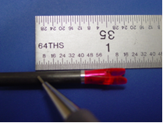

2

3. Remove the wraps from the backing and align the base line with the pencil mark. Place the widest edge on the shaft first and align to make sure the solid line is straight with the arrow. Roll the wrap around the shaft making sure there are no air bubbles. Rub your finger along the shaft to ensure good adhesion and to work out any air bubbles.

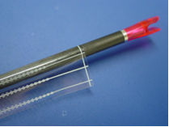

3

4. The arrow can also be laid on the edge of a table and rolled to evenly apply the wrap to the shaft.

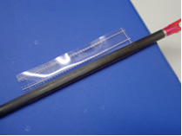
4
5. You arrow is now ready to apply your vanes. Apply the double stick tape as normal. Align the tail edge of the vane with the base line on the wrap. Use either the straight or offset lines based on your preference. Secure the front and back of the vane with tape. You are now ready to shoot! If you damage a vane, just remove it, rub-off the double stick tape and you are now ready to put on a new vane.

Precautions:
Do not attempt to scrape off the double sided tape or the pin striping as you will damage the wrap.
Do not use solvents to clean the wrap or you may cause the lines to fade.

