Hardy Ward’s
Art of Archery
October 10, 2015

Mastering the Art of Archery

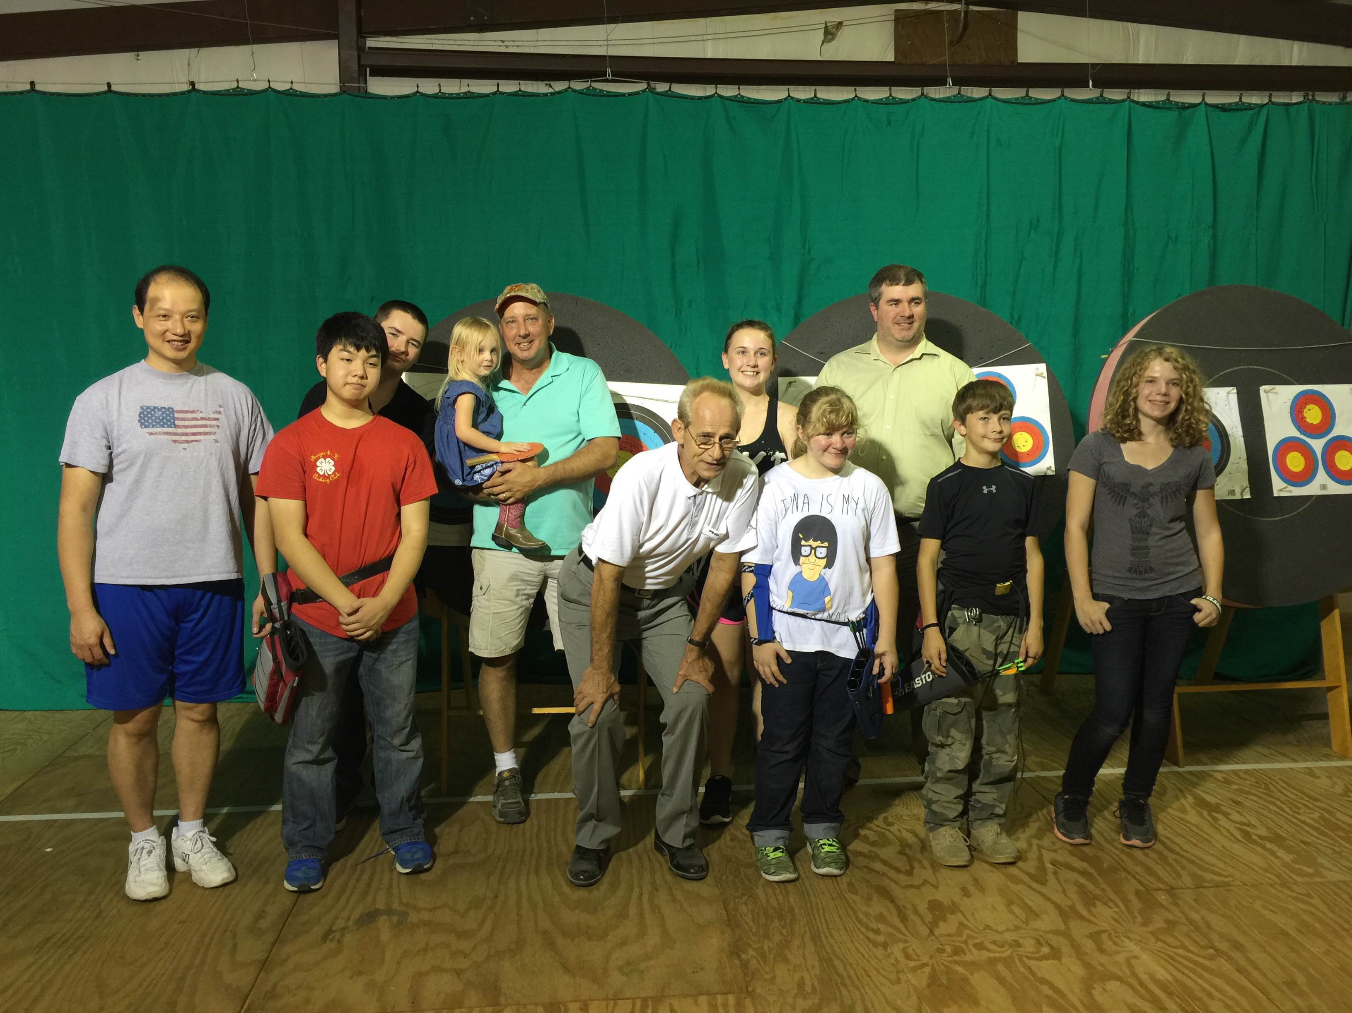
Texas State Archery Association and the Phoenix Gold JOAD Club hosted an informative coaching seminar with an archery legend, Hardy Ward. Hardy has been conducting seminars recently in the US again, and Texas got a real opportunity to have him discuss his coaching method.
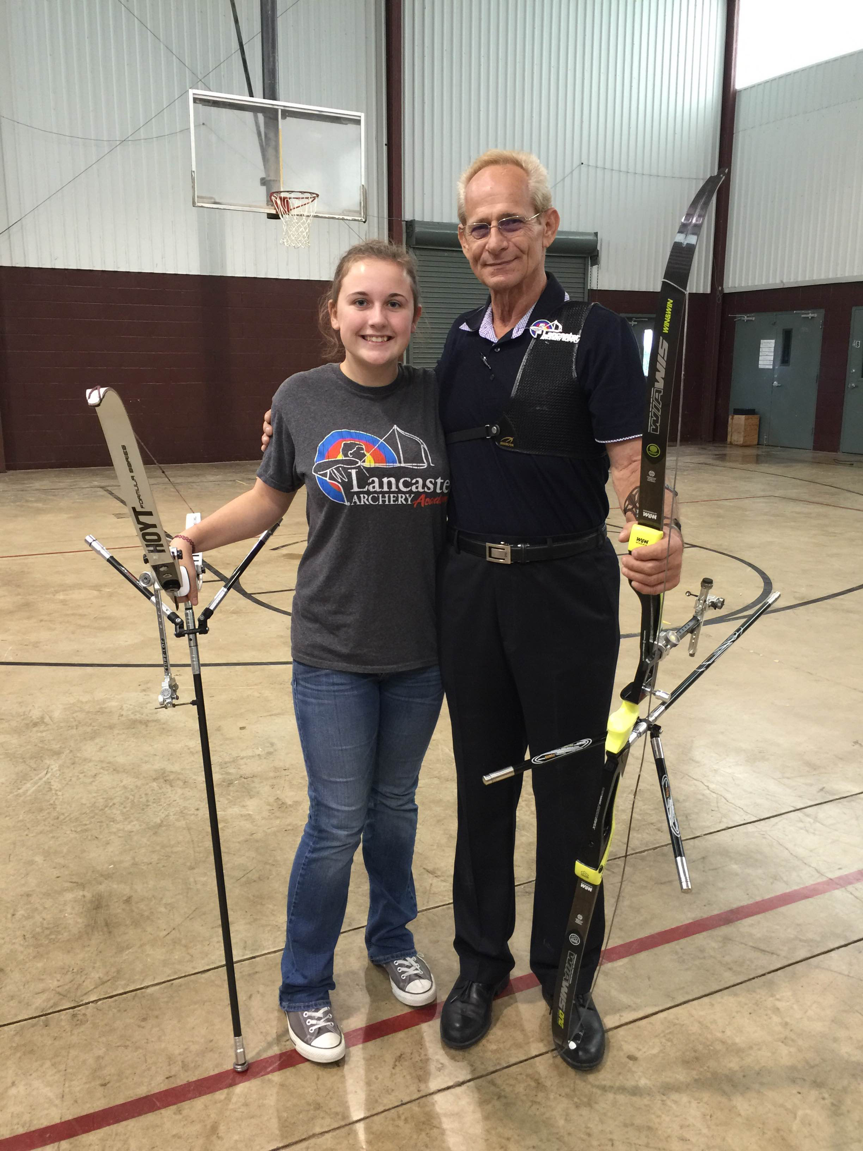
A little background on Hardy. In the late 70’s and early 80’s, Hardy was conducting coaching seminars at US Nationals, for international guests wanting to learn how Americans shot so well. He was approached by the Taiwanese team to find them a coach that would come over and teach them how to shoot. Hardy made many enquiries among his fellow coaches, but none took the offer by the Taiwanese delegation. So the Taiwanese asked him to come over.
He politely said no by requesting an outrageous sum of money and perks, and well as they say, the rest was history. Hardy put in place for the Taiwanese government, an archery program to develop young archers and quickly bring them up into the international ranks. A little background on this, the South Koreans, Taiwanese, Japanese and Chinese use his method of shooting.
He is retired now, but saw the need to reintroduce archery in its original “Form” back to America. He has developed over many years, a classic form that in it’s most true sense, the most efficient way to correctly execute a shot. There is no discussion of “getting into your back” or “transferring load”. That is all secondary and automatic if you follow Hardy’s methodology. His discussion is about triangles and how those collapse into themselves as the shot sequence is executed. One truly has to see the seminar in action to understand and “feel” what is happening in the shot.

This text is not necessarily about changing Form, but for how it’s used that makes the difference....

-Hardy Ward
We had 18 students over two days. Most came from the Bryan/College Station area, but we had one student as far away as Shreveport, Louisiana. Everyone was either a current shooter or coach. Several were level 3’s at the seminar.
He is very good at being very repetitive to get his point across. We used a 3 foot wooden dowel as a training tool, as well as stretch bands and static bands to understand “the Form”. We spent a great deal of time in discussion about what he is teaching and spent a good two hours on the dowels and bands to understand the “Form”.
After lunch, we got to work on the bales and putting what we had learned into practice and to get hands on training from Hardy. From my own experience, this was the first time in years that my shoulders did not hurt while executing a shot sequence. I have made it to the 3 NTS coach level and knew that the only way I could coach it is if I use the method I am teaching. My shoulders have been sore or hurt for most of my shooting career, which spans almost 30 years now, so for me to make the statement that my shoulders did not hurt, is big. After working on the “Form” for a while, like two hours and over 100 arrows, I was still without pain or stiffness. And having laid off shooting for 6 weeks and to shoot that much was amazing to me. I was through the clicker at whatever speed I chose, and had consistency the whole time.
Many of his students that day expressed similar thoughts about what they felt differently about shooting with his methods as well. One of my friends from college days attended and he emailed me recently to say he was shooting 310 or better at 70 meters in his practice sessions, something I bet he has not seen in some time.
I know that I will be working much more with Hardy of the coming year and hopefully bring him back to Texas for more seminars. I believe that this might just be the trick for our elite archers to really step up their game.
There is also a Facebook and web presence for Hardy’s method, Mastering the Art of Archery FB page and www.masteringtheartofarchery.com. In the months to come, Hardy will be updating and inspiring archers with his teachings and methodology on these two sites.

